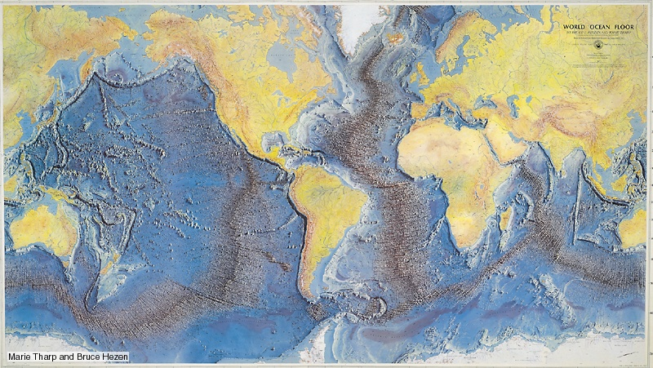
17.3: New Evidence of a Dynamic Earth - notes Name: ________________
Discovery during WWII
- Sonar readings: Atlantic ocean floor wasn’t flat
- It has crevasses, trenches, mountain ridges and volcanoes
- Mid Atlantic Ridge – runs down the middle of the Atlantic ocean from north to south
- Trenches were found at the edges of some continents
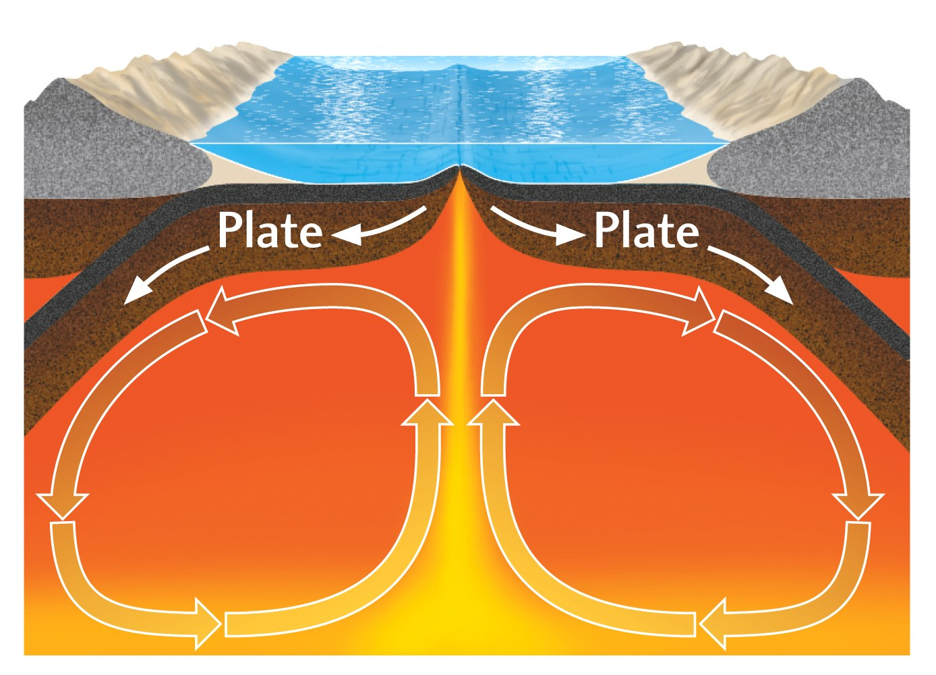
- So the Sea floor is spreading, but how?
- Undersea volcano video
Mantle Convection
- Giant convection cells within the upper mantle (asthenosphere) drag the plates along laterally.
- Where convection rises: sea floor spreading takes place.
- Where the convection cells descend they drag crust down, causing subduction
- Where does the heat come from?
- http://www.absorblearning.com/media/item.action?quick=12n
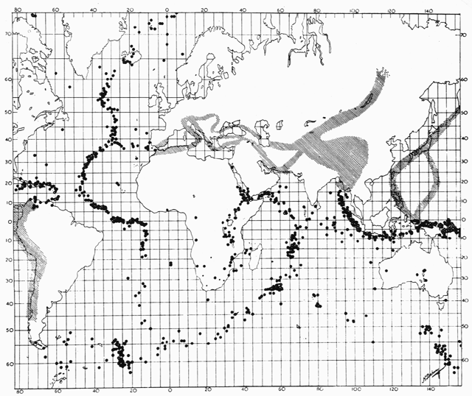
Evidence for the theory of Plate tectonics:
- Volcanic eruption patterns

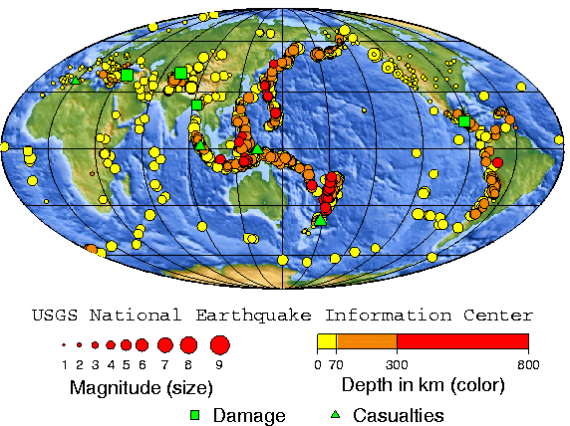

- World Earthquake patterns
http://www.nelson.com/nbcsp10otr/bcsp10otr/Attachments/j_animations/plate_boundaries.html

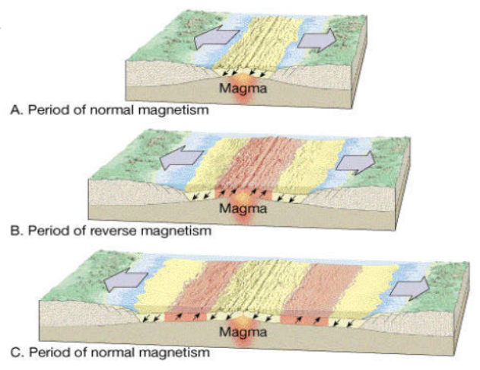
- Magnetic Reversals
- The magnetic stripes are products of steady creation of new ocean crust over geologic time – as the earth’s north and south poles switch every 500,000 years approximately.
http://www.wwnorton.com/college/geo/animations/magnetic_reversals.htm

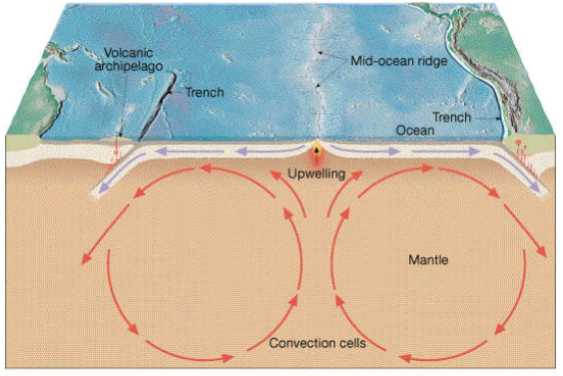
- Radioactive Dating
  - Rock near mid ocean ridges is younger than rock near trenches

http://www.wwnorton.com/college/geo/animations/sea_floor_spreading.htm

Summary of the magnetic reversals and radioactive dating evidence:
- http://www.windows2universe.org/earth/interior/seafloor_spreading_interactive.html

