**Kinetic Molecular Theory Practice**

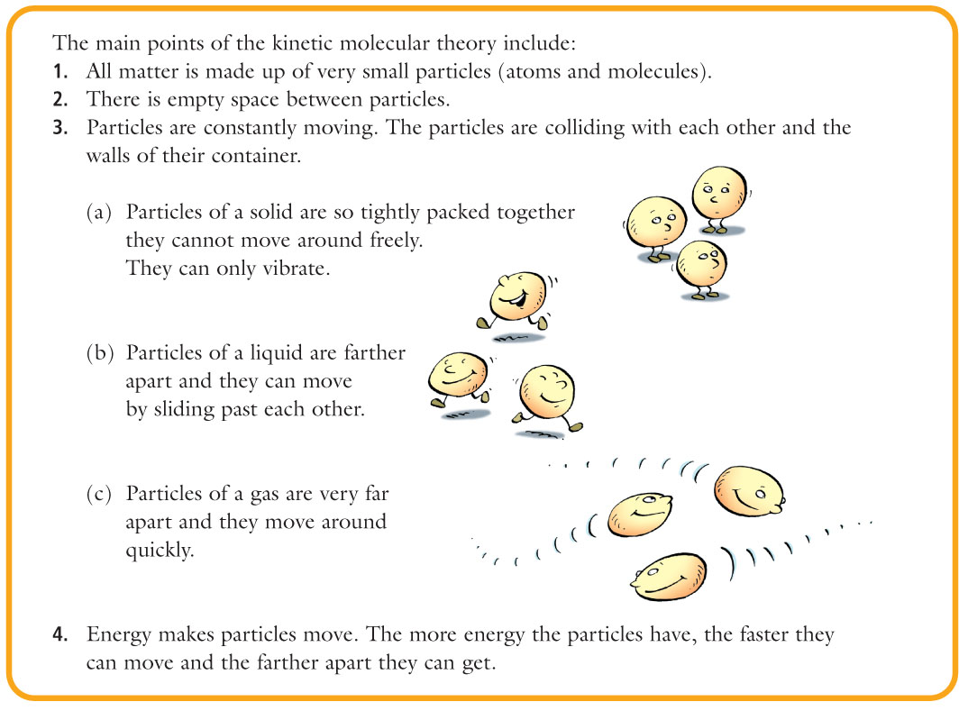



Using the diagrams on the previous page - complete the following table.

|  |  |  |  |
| --- | --- | --- | --- |
|  | **SOLID** | **LIQUID** | **GAS** |
| **Takes the shape**  **of its container?**  **(yes/no)** |  |  |  |
| **Fixed volume?**  **(yes/no)** |  |  |  |
| **How do the particles move?** |  |  |  |
| **How much space is between the particles?** |  |  |  |
| **How strong are the attractive forces between the particles?** |  |  |  |
| **How much energy do the particles have?** |  |  |  |
| **What is an example of something in this state of matter?** |  |  |  |