CHANGES OF STATE Practice

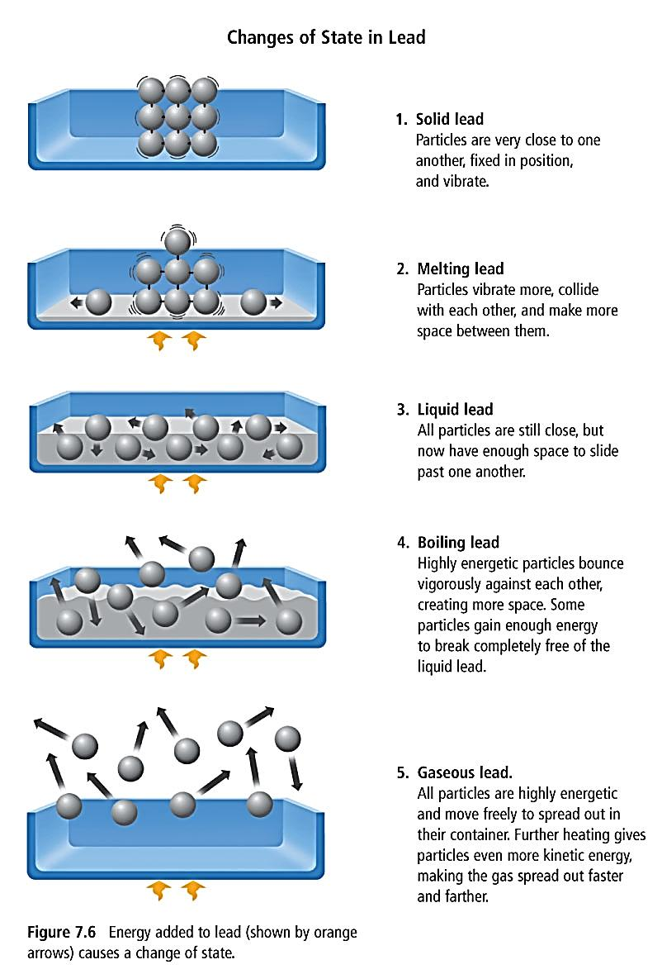

Using the information from the previous page – do the following:
Change from Liquid to Gas
- What happens to the amount of energy?
- What happens to the amount of space between the particles?
- What happens to the movement of the particles?
- What happens to the attraction between particles?
- What happens to the volume of the substance?

Use the following words to label the diagram above - solid, liquid, gas, melting, solidification, evaporation, condensation, sublimation, and deposition

