Triple Beam Balance and Volume Reading/Calculation Practice
Record the mass shown on each balance. Include units.
- _________ | 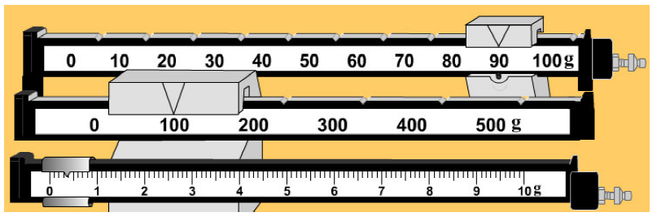
- _________ | 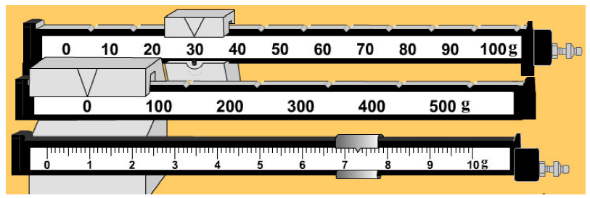
- _________ | 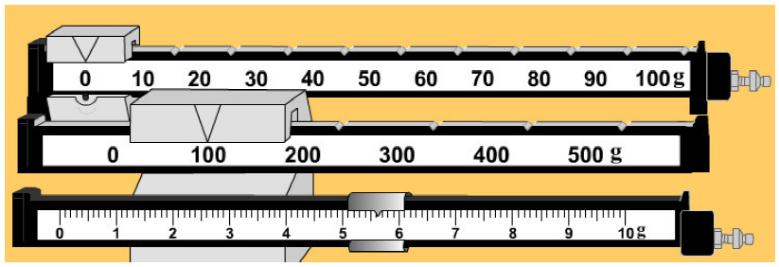
- _________ | 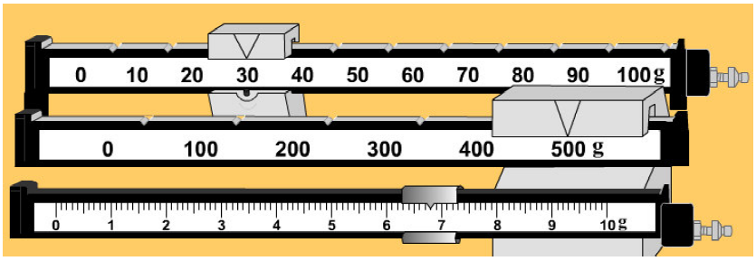
- _________ | 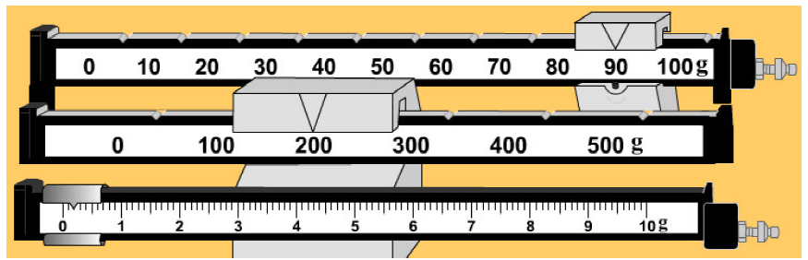
- _________ | 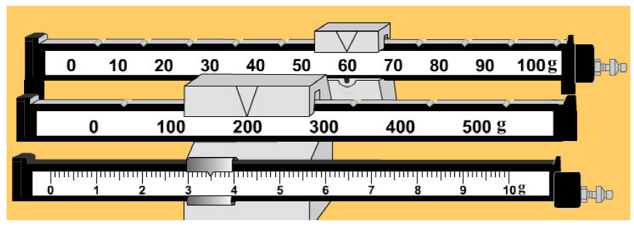

Record the volume for each of the following liquids: (remember units)
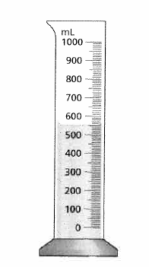 | 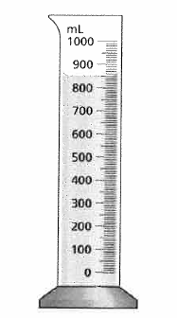
- ______________ | - _____________
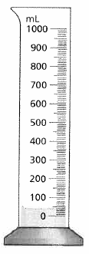 | 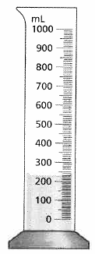
- _____________ | - ___________
Complete the following volume questions:
Length – 5cm, width 2cm and height 3cm – what is the volume in cm³ and mL?

Length – 3 cm, width 1cm and height 4 cm – what is the volume in cm³ and mL?

