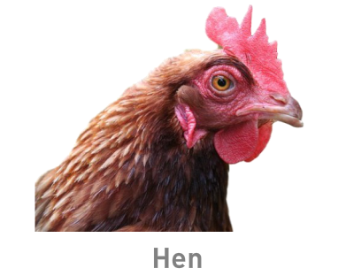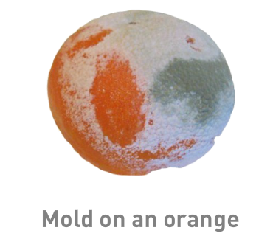

Circle the ones that you think are living.

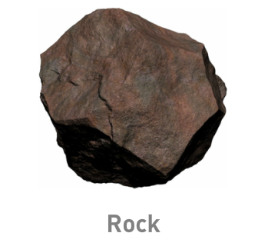

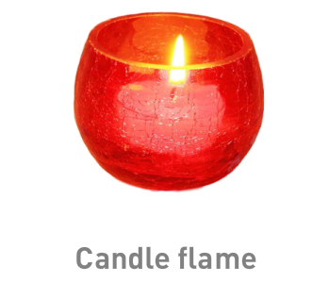

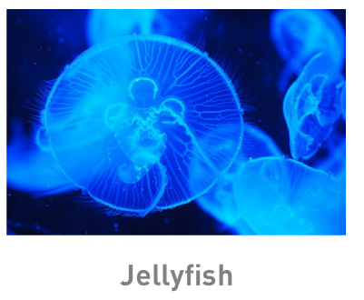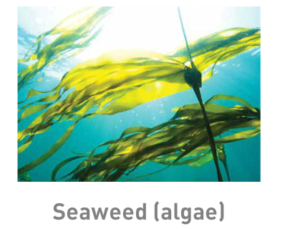

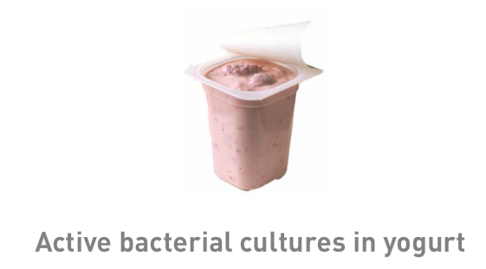

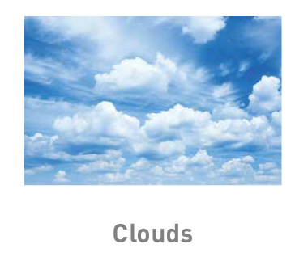

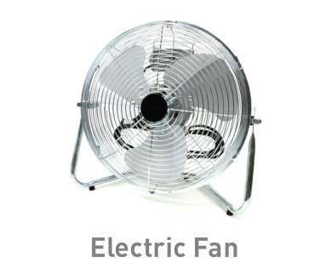

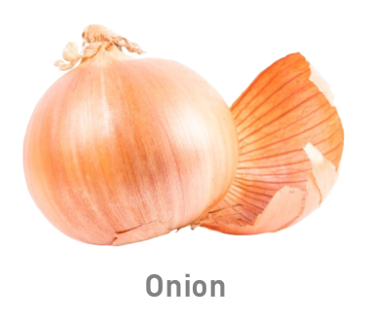

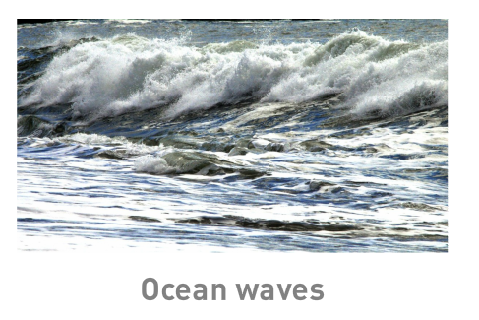

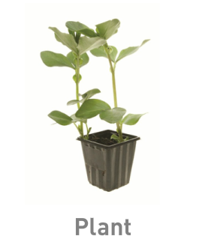

Based on the ones that you circled as living, what qualities do they process that the non-living things do not

**Cell Theory**

After observing cells of plants and animals, scientists have developed this theory:

1. All living things are made up of **____________** cells
2. All new cells come from **_______________** cells
3. 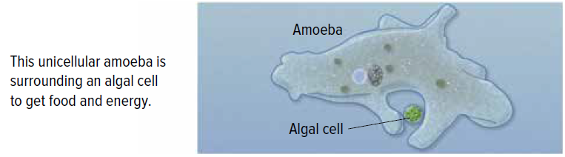The cell is the **____________** of life

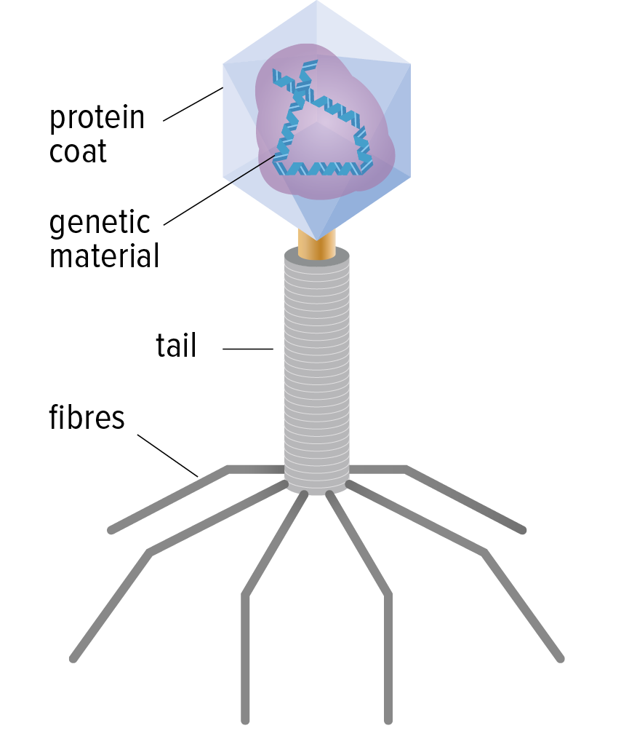**Are Viruses alive?**

* Contain a strand of **______________** surrounded by a protein layer (coat)
* Can **________** and **_____________** in a host cell
* Do not contain other cell parts so cannot **_________** nutrients, _______ energy or **_________** waste
* Need to be **_________** a cell of another organism (host) to reproduce
* Can stay **____________**for hours to months (ex. the flu can stay dormant on a surface for up to **______________**)

What do you think? Are they alive or not?

Argue your decision: