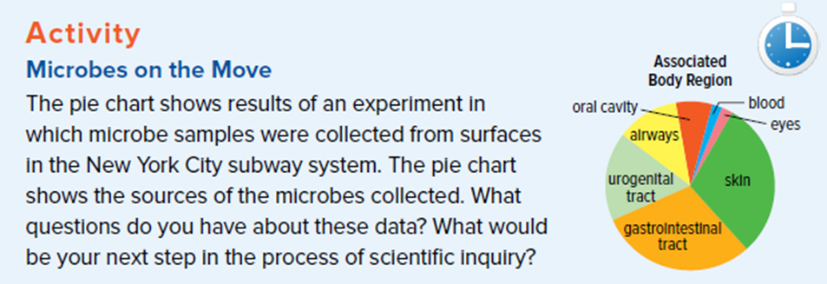

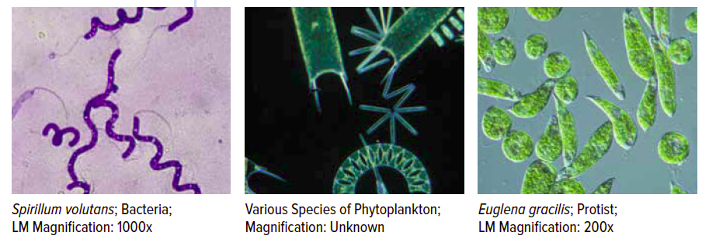
Micro-organisms (Microbes)
  - Smaller than _________
  - Can only be seen with a ____________
  - Live ________ and _______ other living things
  - Live in the _________, ___________, and _________
  - Live in various ____________

Read the textbook section about Microbes and fill in the following chart:
Positive Interactions  Between Humans and Microbes | Negative Interactions  Between Humans and Microbes
Investigation into Microbes
http://www.childrensuniversity.manchester.ac.uk/interactives/science/microorganisms/micro-organisms/
(take notes and include examples)

Bacteria | Viruses | Protozoa
Fungi | Algae

Find a micro-organism in the “Interactive House”
- Choose a location and then find a positive and negative micro-organism (read the information and fill in the chart)

Negative Microbe | Positive Microbe
Location: | Location:
Organism name: | Organism name:
Type: | Type:
What does it do? | What does it do?

