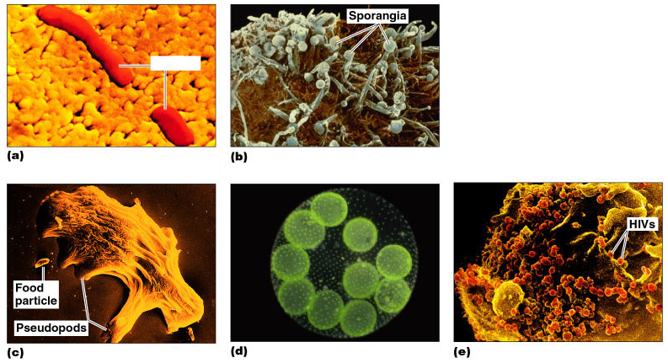
Let’s Review: Think back to last week…
- Micro-organisms fall into 5 categories – list them and then label the pictures to the right?

- Which ones are pathogens and thus cause diseases?

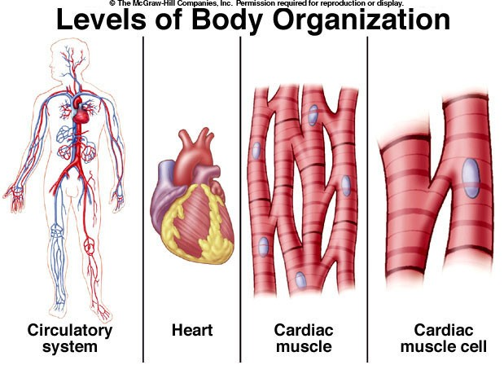
Next, we are going to learn about how our bodies fight back against these pathogens.
- Levels of Body Organization (use the following terms to label the diagram to the right)
  - Cells
  - Tissues
  - Organs
  - Organ Systems

- See what Organs you know – try this quiz:
http://www.softschools.com/science/human_body/diagram/

- Match the following Organ System names to the images below (muscular, digestive, respiratory, circulation, nervous and skeletal):
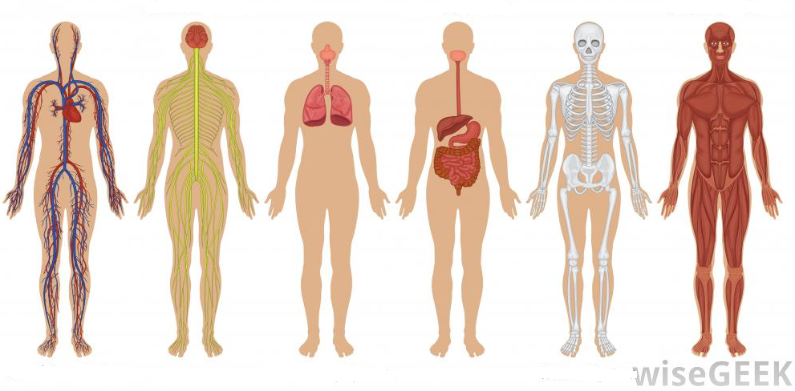

- Which systems on the bottom of the previous page do you think are most related to the transmission of pathogens (disease causing micro-organisms)?

- Explain why you chose those systems?

Let’s look a bit closer at Circulation:
Check out the following interactive animation of the heart - http://bit.ly/interactiveheart
Use the information from the animation to label the diagram of the heart below with left atrium and right atrium and left ventricle and right ventricle. Also match the descriptions below to the correct chamber:
- Blood lacking oxygen from the body enters this chamber
- Oxygen rich blood enters this chamber from the lungs
- Blood lacking oxygen from the body exits this chamber towards the lungs
- Oxygen rich blood head from this chamber out in to the body

