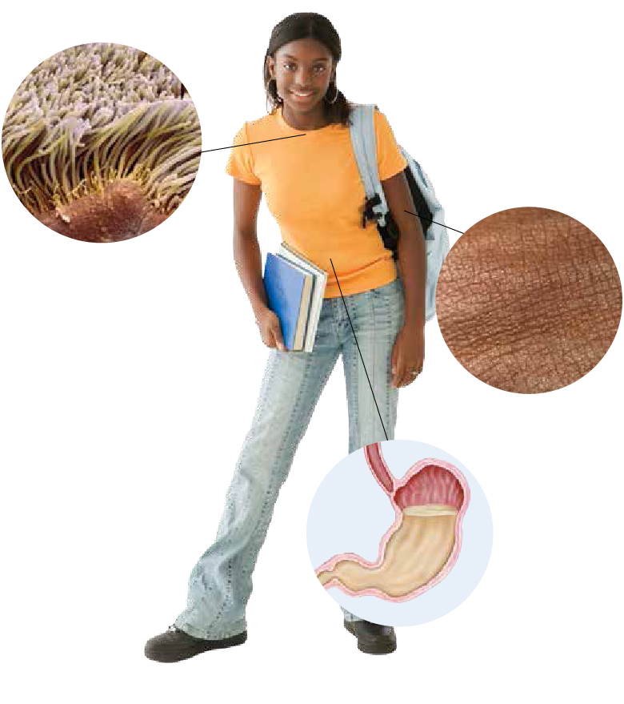**1st Line of Defence:**

1. **Skin**
   1. a physical **__________** that keeps pathogens from **___________** the body
   2. **_________** and natural body **_______** **______** some pathogens on the surface of the skin
   3. skin is **_____________**so you can **___________** pathogens off of it
2. **Respiratory System**
   1. **_______** and **________** (**__________** hairs) in your nose and throat **________** pathogens and move them out of your body
   2. **__________** traps pathogens when you cough, **________** and swallow you remove the pathogens from your body
3. **Digestive System**
   1. Strong **________** in your stomach **______** many types of pathogens
   2. **_________** traps pathogens and **___________** removes them from your body

**2nd Line of Defence**

1. **White Blood Cells/Macrophages**
   1. **__________** and kill pathogens
   2. Release **_____________** that makes it easier for **_________** white blood cells to kill pathogens
2. **Inflammation**
   1. Your bodies response to an **___________** or **__________**
   2. The affected area becomes **________** and **____________**
   3. White blood cells **__________** to the area and kill the pathogens

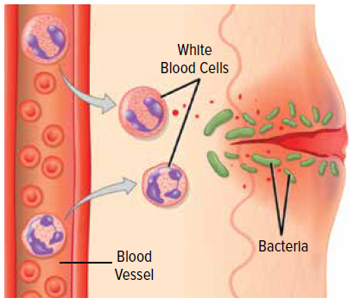

**3rd Line of Defence**

1. **T-cells**
   1. White blood cells that fall in to **______________**
      1. **___________** T-cells – directly kill some pathogens
      2. **___________** T- cells – release chemicals to communicate with B-cells
      3. 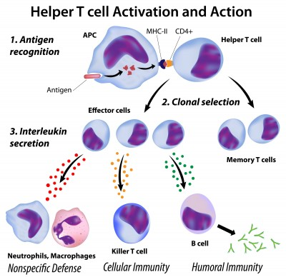**_________** T- cells – remain in the lymph nodes and fight **________** infections
2. **B-cells/Plasma Cells**
   1. White blood cells that make **_____________**
3. **Antibodies**
   1. **__________** that **_______** with **____________** on the outside of pathogens and mark them for **_______________**