You will be assigned one of the following diseases. Circle it
Anthrax
Avian Influenza
Clostridium difficile (C.diff)
Ebola
E. coli
Flu (Influenza)
Giardiasis
Meningitis - viral
Meningitis - bacterial
Meningitis - fungal
Meningitis – amebic
Rhinovirus
Salmonella
Staphylococus Aureus
Streptococcus pneumoniae
Tuberculosis (TB)
Zika Virus
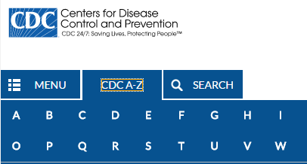
Use this link to find some information about your disease - https://www.cdc.gov/DiseasesConditions/
- Name of your disease: _______________________________________

- Is it a virus, bacteria, protist, fungus or algae?

- Is it eukaryotic or prokaryotic?

- How does it get into your body? Which system does it enter through? (digestion, respiration, circulation, nervous, muscular, skeletal or urinary)

- Which system or systems does it affect and How?

- How does the 1st line of defence protect you from this illness? And if it does not protect you why is that the case?

- How does the 2nd line of defence protect you from this illness? And if it does not protect you why is that the case?

- How does the 3rd line of defence protect you from this illness? And if it does not protect you why is that the case?

- What are some strategies to help prevent you from getting this disease?

- If you were to draw this illness in a supervillain likeness what would it look like?
Presentation: 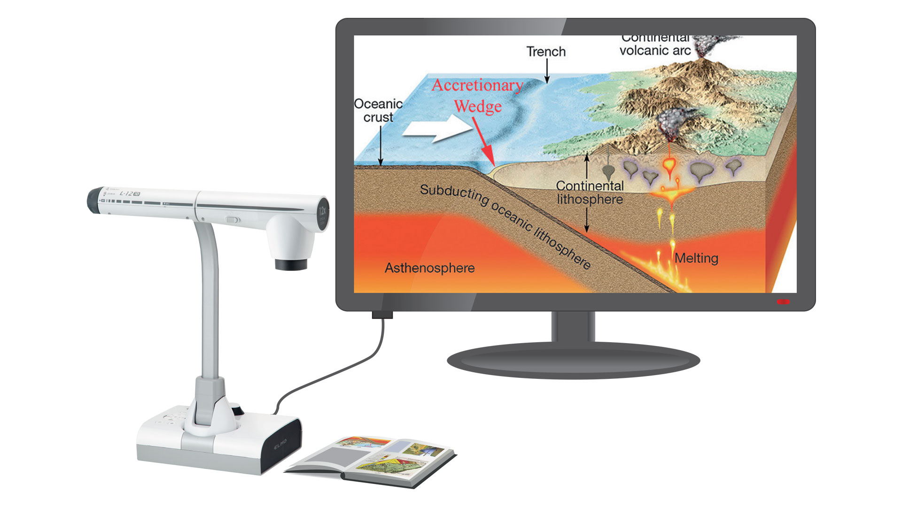
- Show your supervillain picture
- Name of the disease
- Type of cell
- Through which system does it enter the body?
- What system does it affect?
- How can you prevent yourself from getting it?

