Bohr Diagrams – Notes Name: ___________________________
What are they? A way of ____________ an atom – to show _____________, ____________ and _____________
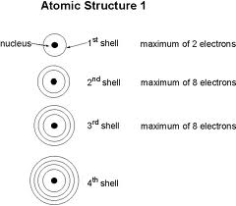
How do you draw them?
- Draw a ___________ for the nucleus
- Include the protons (____) and the neutrons (____) in the nucleus
- Draw __________and fill them with the appropriate ________
  - Shell 1 – can have ___ electrons
  - Shell 2 – can have ___ electrons
  - Shell 3 – can have ___ electrons
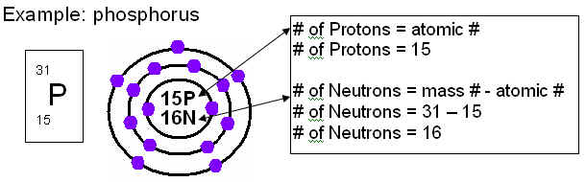
- We will only draw the first _____ elements as Bohr diagrams – so we will only use the first ____ shells.
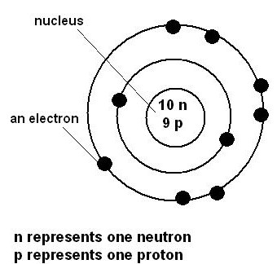
Now let’s practice together:
Atom of Nitrogen | Ion of Nitrogen N³⁻
Atom of Beryllium | Ion of hydrogen H⁺
Now – you practice on your own
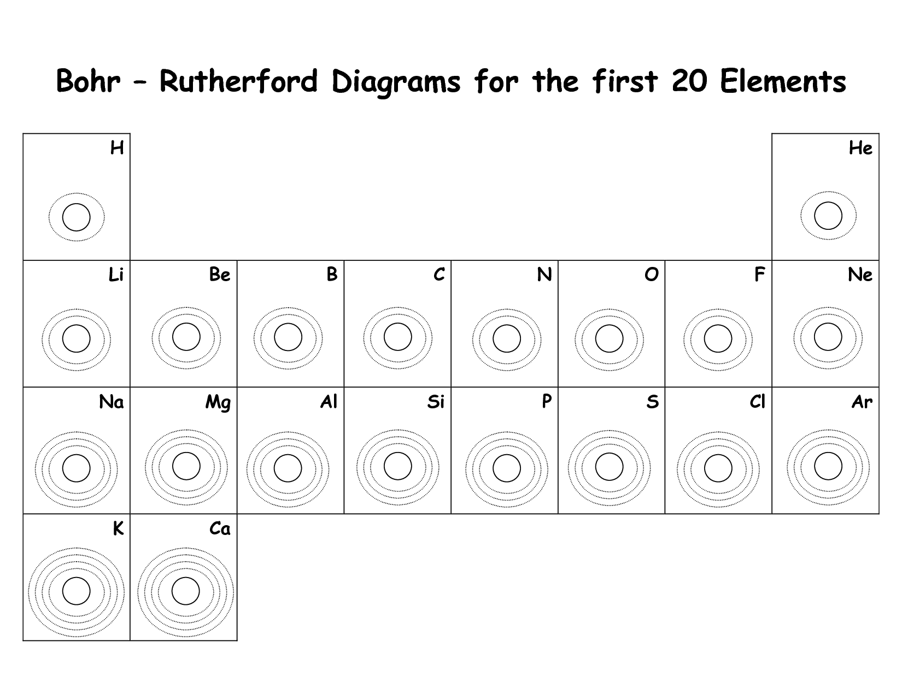
Draw – the following – as neutral atoms
Now, draw the following as ions:
Beryllium 2+ | Chlorine -1
Calcium 2+ | Phosphorus -3

