Bohr Diagrams – Notes Name: ___________________________
What are they? A way of drawing an atom – to show protons, neutrons and electrons
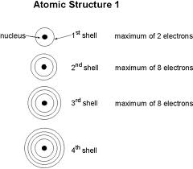
How do you draw them?
- Draw a circle for the nucleus
- Include the protons (p) and the neutrons (n) in the nucleus
- Draw shells and fill them with the appropriate electrons
  - Shell 1 – can have 2 electrons
  - Shell 2 – can have 8 electrons
  - Shell 3 – can have 8 electrons
- We will only draw the first 20 elements as Bohr diagrams – so we will only use the first 3 shells.
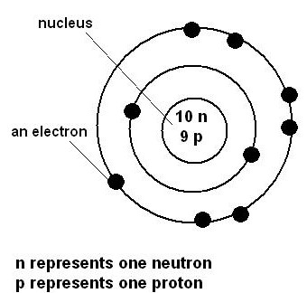
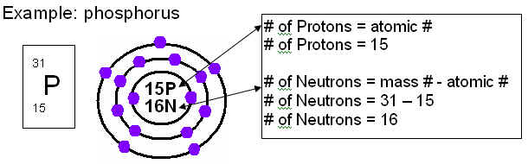
- When drawing an ion – add or subtract the appropriate # of electrons to make the outer shell full

Now let’s practice together:
Atom of Nitrogen | Ion of Nitrogen N³⁻
Atom of Beryllium | Ion of hydrogen H⁺

Now – you practice on your own
Draw – the following – as neutral atoms
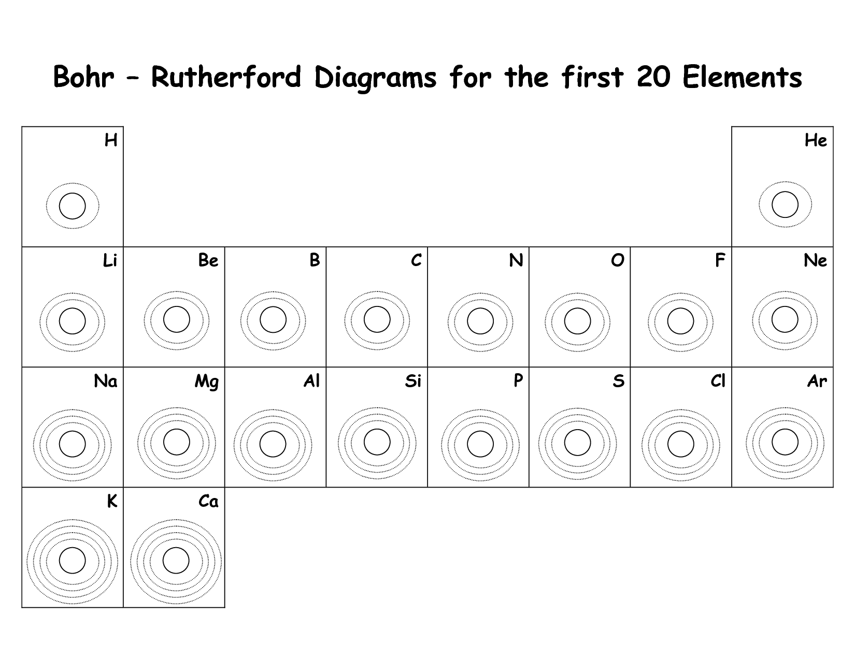
Now, draw the following as ions:
Beryllium 2+ | Chlorine -1
Calcium 2+ | Phosphorus -3

