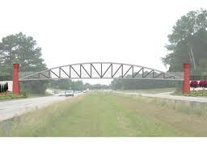
Bridges – rules to remember
Strongest shape – a curve
Second strongest shape – an equilateral triangle

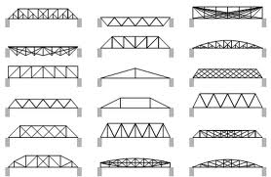
So support any curve with triangles
Simple is better
Your bridge is only a strong as its weakest point
Prototypes
Start to a build a section – so you can decide on glue type, size and shape.
Bring the section or a picture (of that section) to the meeting at lunch in W205 on Thursday, November 8th
Work habits are related to these steps getting done. – no sketch, or prototype – no “G”

