**Cell Membrane – Notes Page 1 Name: ___________________________________**

**Parts and Functions**

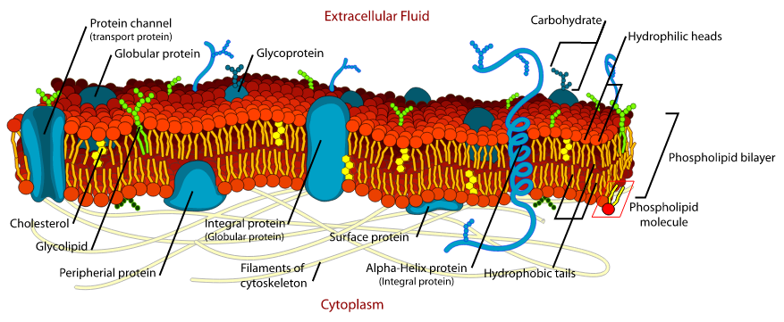

|  |  |  |  |
| --- | --- | --- | --- |
| **Part** | | **What does it look like/where is it?** | **Function** |
| Phospholipid bilayer | |  |  |
| Cholesterol | |  |  |
| Glycolipids | |  |  |
| Peripheral proteins | Receptors |  |  |
| Enzymatic |  |  |
| Integral proteins | Channel Proteins |  |  |
| Carrier Proteins |  |  |
| Glycoproteins | Recognition proteins |  |  |
| Cytoskeleton | |  |  |

**Try This:**



1. Label W, X, Y, and Z
2. Which labelled structure is responsible for cell recognition and communication?
3. What is this structure called? ______________________________