Cell Structures
P/A Cells? | Organelle |  | Description/Structure | Function
 | Nucleus
 |  | Nuclear Membrane/ Envelope
 |  | Nucleolus
 |  | Chromatin
 |  | Chromosome
 | Ribosomes
 | Endoplasmic Reticulum | Rough ER
 |  | Smooth ER
 | Vesicles
 |  | Lysosome
 |  | Peroxisome
 | Golgi Apparatus
 | Mitochondria
 |  | Cristae
 |  | Matrix
 | Chloroplasts
 | Vacuoles
 | Cytoplasm
 | Cytoskeleton
 | Cell Wall
 | Cell Membrane

Identify the cell structures labeled in the following diagrams.
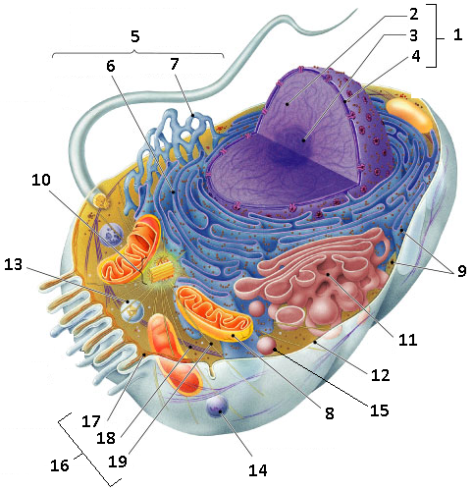
Type of Cell:

- centriole

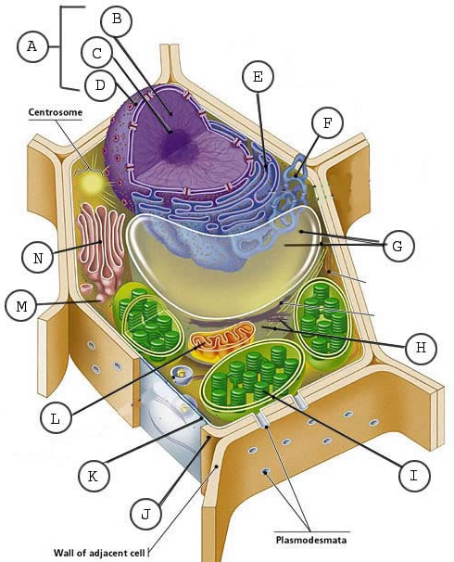

Type of Cell:

