**Science 10: 17.1 (page 493) - Layers of the Earth** Name: _________________________

Fill in the blanks in the **following picture** of the earth:  
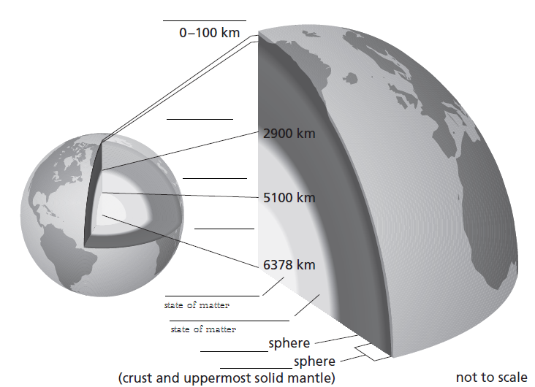

**Layers of the Earth:**

|  |  |  |  |
| --- | --- | --- | --- |
| **Layer** | | **Description:**  *What is it made up of?* | *How thick is it?* |
| Crust | |  |  |
| Mantle | Lithosphere |  |  |
| Asthenosphere |  |
| Lower mantle |  |
| Core | Inner Core |  |  |
| Outer Core |  |

**Avocado Dissection:**

In group of 4:

1. Take an avocado, 4-5 toothpicks and small piece of tape
2. Carefully cut open the avocado and then using your understanding of the earth layers – label (with toothpick flags or just tape) the crust, lithosphere, asthenosphere, lower mantle and core (inner and outer).

|  |
| --- |
| **How are the structures of an Avocado and Earth similar? (list at LEAST 5 similarities)** |
|  |
| **How are the structures of an Avocado and Earth different? (list at LEAST 5 differences)** |
|  |