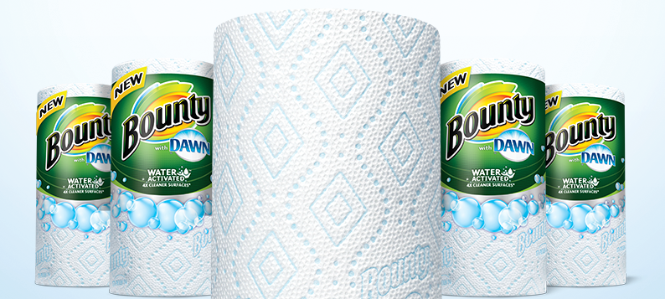
DESIGN LAB: IS BOUNTY BETTER
Many companies make CRAZY claims about their products in an attempt to seduce more customers. Your job, as a scientist is to determine whether their claims are legitimate… or BOGUS!.

BOUNTY Paper Towel Claims to be “2x more absorbent than the leading brand”. They also claim to be “super durable” and also “super clean”.

Your Task: Create an experiment that determines if Bounty is really “better” than store-brand paper towel.

Available Materials:
You will have access to the following materials to use in your experiment. You don’t have to use everything!
Safety Goggles  Bounty paper towels  Store-brand paper towels  Graduated Cylinders | Beakers  Tape  Metal Washers  Water | Table  Stopwatch  Electronic balance (scale)  Other supplies - please be specific ________________

INSTRUCTIONS: Complete all work on the “Experimental Design” Template on the next pages

PART 1: DESIGN YOUR EXPERIMENT (criterion B) _________
- Choose what brand claim you’ll investigate & test. (Durability or absorbency of bounty?)
- Design a question that you will answer by completing this investigation
- Create and explain a hypothesis you’ll test in your investigation that is based on your question. It should be in an “if….then…..because…” format.
- Identify your variables (independent, dependent, and controlled)
- Design a logical, complete and safe method
  - Identify materials that you’ll use (including specific quantities)
  - Create a complete and detailed step-by-step method that you will follow the day of the experiment.
- Create a data table in which you’ll record your data when you carry out the experiment. All data tables should have a title, appropriate headings, and units.
PART 2: COMPLETE YOUR EXPERIMENT! (criterion C) __________
- Follow your method & make observations
  - collect your data in your data table
  - Transform your data to make results obvious (find averages, graph, other calculations, etc.)
- Analyze your results by interpreting your data and describing what it means, using scientific reasoning
- Assess the validity of your experiment
  - Explain if your hypothesis was valid
  - Explain if your method was valid
  - Describe any improvements or extensions that would improve your investigation if you were to repeat it in the future.

PART 3: SHARE YOUR FINDINGS! __________
- Prepare & share a 4-slide presentation to share your investigation
(slides: Question, Findings, Conclusion, Errors/Improvements)

IS BOUNTY BETTER - EXPERIMENTAL DESIGN
Use the instructions from the first page to complete the following parts of your experimental design.
TYPE YOUR WORK IN A DIFFERENT COLOUR

Criterion B: Inquiring and Designing
(0) | Beginning (1-2) | Developing (3-4) | Accomplished (5-6) | Exemplary (7-8)
I have not achieved a standard described by any of the descriptors to the right. | I am able to:  state a problem or question to be tested by a scientific investigation, with limited success  state a testable hypothesis  state the variables  design a method, with limited success. | I am able to:  state a problem or question to be tested by a scientific investigation  outline a testable hypothesis using scientific reasoning  outline how to manipulate the variables, and state how relevant data will be collected  design a safe method in which he or she selects materials and equipment. | I am able to:  outline a problem or question to be tested by a scientific investigation  outline and explain a testable hypothesis using scientific reasoning  outline how to manipulate the variables, and outline how sufficient, relevant data will be collected  design a complete and safe method in which he or she selects appropriate materials and equipment. | I am able to:  describe a problem or question to be tested by a scientific investigation  outline and explain a testable hypothesis using correct scientific reasoning  describe how to manipulate the variables, and describe how sufficient, relevant data will be collected  design a logical, complete and safe method in which he or she selects appropriate materials and equipment.

PROBLEM – What problem will you answer by completing this experiment? Include background about Bounty, scientific explanation of how Bounty claims to be more absorbent or more durable and include relevant details about all components of your question. Note: This section must be supported by research (citations below) and should be at least 4 to 5 sentences.

Website name | Title of webpage | URL

HYPOTHESIS – What hypothesis will you test in this experiment? This should be in an “if….then…because statement”. For example: “If sample B is a frog, then it will be able to swim and croak, because frogs are aquatic
organisms and are known to vocalize with a croaking sound”
Note: the reason at the end of your statement must be supported by scientific reasoning (found in your research) - not just your own personal beliefs.

VARIABLES –What are the variables in your experiment?

My Independent Variable is:
My Dependent Variable is:
My Controlled Variables are:

How will you measure the dependent variable? be specific!

How many times will you repeat the experiment so that you can get as accurate and complete results as possible? Justify your decision.

MATERIALS – You will have the following materials available to you. Check the boxes beside the materials you will use for your experiment!
- Bounty paper towels (x______) Any other materials? List below:
- Store-brand paper towels (x______)
- Beakers (x______)
- Graduated Cylinder
- Tape
- Metal Washers/Other Weights
- Table
- Stopwatch
- Water
- Electronic Balance
METHOD – Create a set of instructions you’ll follow during the lab. Make sure to make a complete list of steps and
include any diagrams of equipment you’ll set up! Include required safety measures that should be taken during the experiment.

DATA/OBSERVATIONS – use this space to create data table(s) in which you’ll record your observations during the lab. You table should have a descriptive title, as well as units in any headings/columns for measurements!

Criterion C: Processing and Evaluating
(0) | Beginning (1-2) | Developing (3-4) | Accomplished (5-6) | Exemplary (7-8)
I have not achieved a standard described by any of the descriptors to the right. | I am able to:  collect and present data in numerical and/or visual forms  accurately interpret data  state the validity of a hypothesis with limited reference to a scientific investigation  state the validity of the method with limited reference to a scientific investigation  state limited improvements or extensions to the method. | I am able to:  correctly collect and present data in numerical and/or visual forms  accurately interpret data and describe results  state the validity of a hypothesis based on the outcome of a scientific investigation  state the validity of the method based on the outcome of a scientific investigation  state improvements or extensions to the method that would benefit the scientific investigation. | I am able to:  correctly collect, organize and present data in numerical and/or visual forms  accurately interpret data and describe results using scientific reasoning  outline the validity of a hypothesis based on the outcome of a scientific investigation  outline the validity of the method based on the outcome of a scientific investigation  outline improvements or extensions to the method that would benefit the scientific investigation. | I am able to:  correctly collect, organize, transform and present data in numerical and/ or visual forms  accurately interpret data and describe results using correct scientific reasoning  discuss the validity of a hypothesis based on the outcome of a scientific investigation  discuss the validity of the method based on the outcome of a scientific investigation  describe improvements or extensions to the method that would benefit the scientific investigation.
TRANSFORM DATA - Review the data from your table above and take averages, create graphs, and/or complete other calculations that help to explain your data further.

ANALYZE DATA - What does your data/results mean? What have your findings revealed (refer to specific data to support your inferences), and how are they explained and supported scientifically? Comment on the reliability of the data – were there any unexpected results or outliers?

VALIDITY OF THE HYPOTHESIS - Was your hypothesis valid (was it validated by your results) or not? ? Discuss whether or not your hypothesis was supported or not supported and use your data as evidence.

VALIDITY OF THE METHOD - Discuss whether your method was valid by answering the following questions: Is your data precise? (Is there enough data? Is your data consistent? Are there any outliers? Why/why not? What sources of error were there in your investigation? Did you control for all extrinsic variables?) Is your data accurate? (if applicable) (does it agree with literature values?) What were sources of error in your investigation? How did they impact the validity of your test?

IMPROVEMENTS AND EXTENSIONS - Describe how could you improve your method so that you could get more accurate and meaningful results and fix some invalid components from the previous section. What extensions to your lab could you make if you were to repeat the experiment in the future (what more could you test).

