The Great Geyser Experiment – A Controlled experiment
Name: __________________
We will conduct this experiment on September 11 – I will provide the geyser tubes and the mentos – you need to provide the diet pop.
- Choose one of the following questions (circle it).
  - How many Mentos creates the highest geyser?
  - What type of Mentos creates the highest geyser?
  - What type of pop creates the highest geyser?
  - What volume of pop creates the highest geyser?
  - What temperature of pop creates the highest geyser?
  - Or another one of your choice –please confirm with the teacher before proceeding.
__________________________________________________________________

- VARIABLES:
Independent: (the variable that will be manipulated in your experiment) __________________
Dependent: (the variable that you will measure during the experiment) ___________________
- HYPOTHESIS: What do you expect will happen in terms of geyser height?
In this format:
If we _______________________________________________________ (independent variable) then the _______________ (dependent variable) will __________________ because_________________________________________________________.
- EXPERIMENTAL CONTROLS: A list of all the factors you will keep the same in each of your trials.

- MATERIALS: A list (including qualtities) of what you will use to conduct the experiment.

- PROCEDURE: all of the steps (in order) that you will take to collect the data
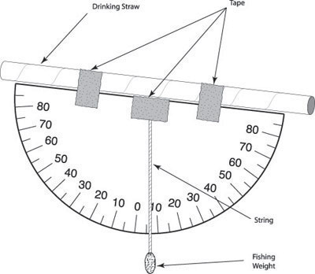
- Observations:
Variable | Height

Conclusion:
- A summary of the results and what they mean.

- Based on your results - determine if the hypothesis was valid. In other words, did you get the results that you expected? If not, why not?

- Based on your results - determine if the method was valid. In other words, did your method help you get the results that you expected? If so, why? and if not, why not?

- What improvements or extensions could be made to your method to make for a better/more accurate scientific investigation next time?

