Digestion Notes (PLO C1 and C2) Name: _____________________
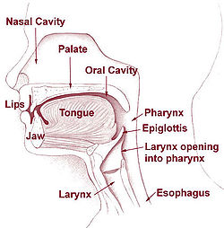
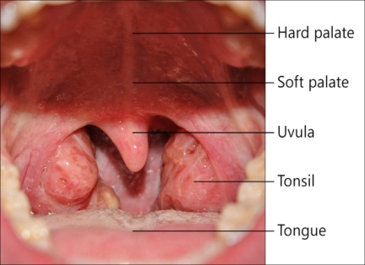
Swallowing: occurs in the __________. During swallowing the soft palate (_______) covers the nasopharynx and the ____________ covers the glottis (the opening to the larynx -voice box))

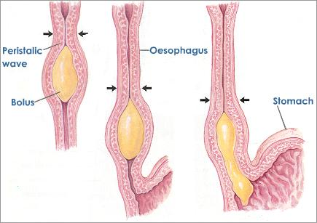
Peristalsis – rhythmic ___________ (of muscles) that moves ______along. Found in the ________________________________________________.

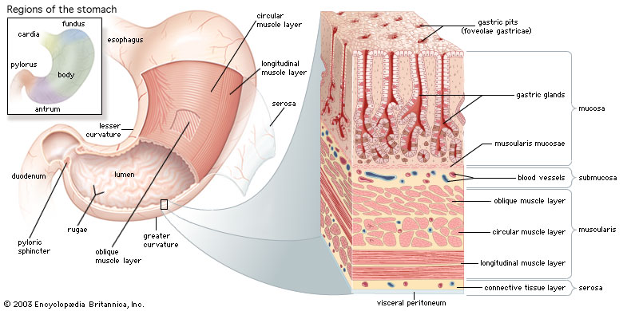
Stomach:
- thick walls, contains ____________ that lead to _______________
- the folds disappear as the stomach grows to ____L max capacity
- ____________ produced by the gastric glands contains ____________ (the precursor for pepsin) (enzyme), ____________ and _________).
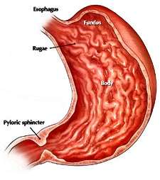
- Hydrochloric acid causes the pH of the stomach to be pH = ____ and helps to break down the food in the stomach along with _____________.
- ___________ protects the walls from the _________ (HCl)
- ________, _________ and __________ are absorbed into your blood stream here.
- empties in about _____ hours and the food is now called _________
- The chime travels through the ___________ sphincter into the small intestine

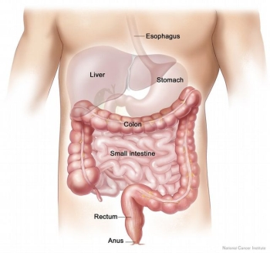
Small intestine: – takes part in __________digestion- with the release of _____________ that break down _______, _________ and _____________.
Also, takes part in _________ digestion – through continued ___________.
Villi: Finger like __________ on the ________ of the small intestine, increase the _____________ available for absorption of ______________.
Microvilli: ____________ extensions that produce enzymes (such as peptidase and maltase) and absorb ______________.
Glucose, amino acids and nucleic acids are absorbed into the __________ capillaries
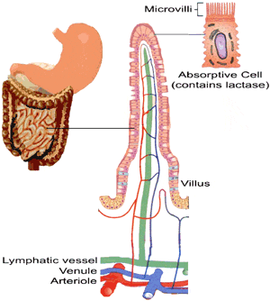
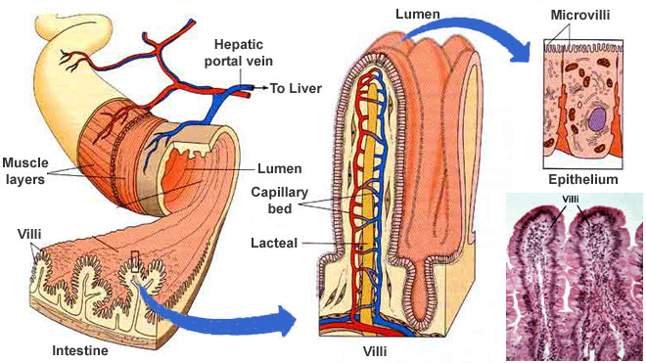
Fats including Glycerol and fatty acids are absorbed into the __________ and enter the _______________ system

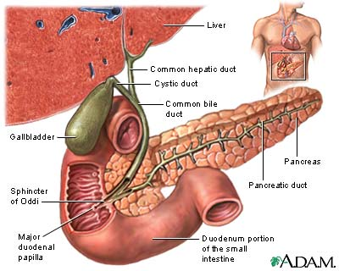
Bile: made in the __________, stored in the ___________, secreted through the _____________ into the _____________. The bile emulsifies _________ – breaks it down into fat _____________.
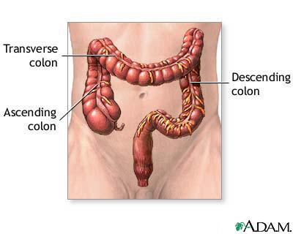
Pancreas: produces ____________ which consists of ___________________, pancreatic amylase, trypsinogen (the precursor for trypsin), nuclease and lipase.

Large Intestine: contains anaerobic (live without ___________) bacteria which break down food and produce _____________ and other molecules which can be _____________.

