DNA Replication - Try This
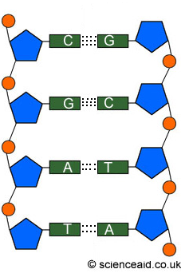
- Label the following image using these words: nucleotide, sugar, phosphate, monomer, polymer, DNA, nitrogenous base, purine, pyrimidine

- Label the following diagram with – parent strand, daughter strand. Add in the hydrogen bonds. Add helicase to show where it would unzip the DNA, add polymerase to show where it will bond the complimentary bases. Circle a free floating nucleotide.
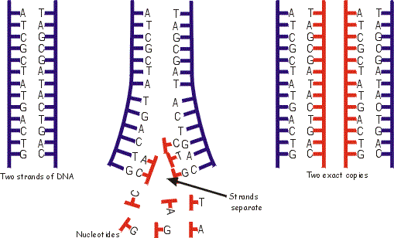

- Based on this diagram, you can see that DNA replication is considered semiconservative – what does that mean?

- Show how the following DNA strands would be replicated (show the steps – unzipping, complimentary base pairing, rebonding). Use different colour pens to show the parent/daughter strands, free floating nucleotides and enzymes (helicase and polymerase).

A - T
C - G
T - A
A - T
G - C
C - G
T - A
A - T

