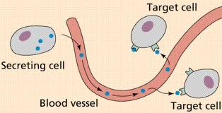
Endocrine System – Notes
How do hormones travel?
Released from _________________. Travel through the ________ – through out the _________ body. Hormones can only bind to specific ______________ on or in the ____________ cell.

How does FSH/LH only stimulate the ovaries and tests?
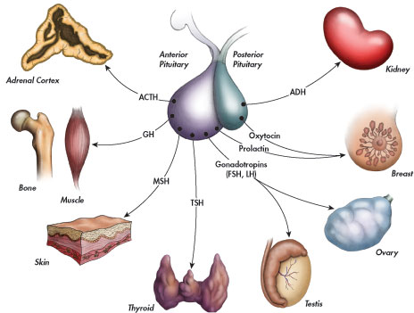
Pituitary Gland
Anterior Pituitary – a ________ endocrine gland
- Cells in the __________ produce ___________hormones (such as GnRH and TRH).
- These hormones are secreted into the ____________ and travel to _____________ cells in the anterior pituitary
- The anterior pituitary produces and releases a ___________hormone to the ___________(such as LH, FSH and TSH).

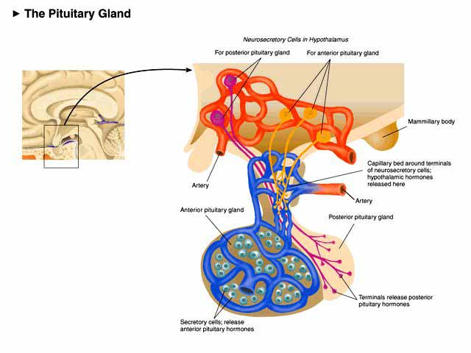

Posterior Pituitary (an ___________ growth of the hypothalamus)

- The ____________ produces some hormones that are stored in the ____________ of the posterior pituitary.
- The posterior pituitary releases these hormones when ________________.
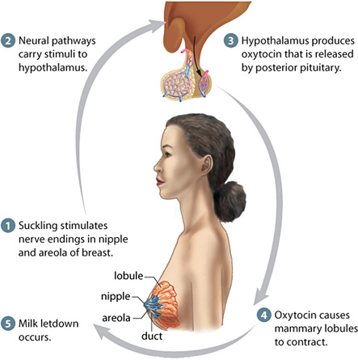
____________Feedback – Breast Feeding and oxytocin ____________ feedback – thyroxin http://www.youtube.com/watch?v=NnIWDxuZKUo
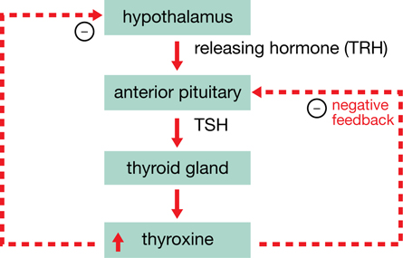

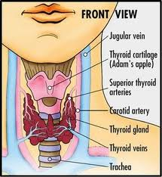

Maintaining Homeostasis – Insulin and Glucagon Adrenal gland
Uses _____________ feedback (http://www.youtube.com/watch?v=V08dWz5XNBA))
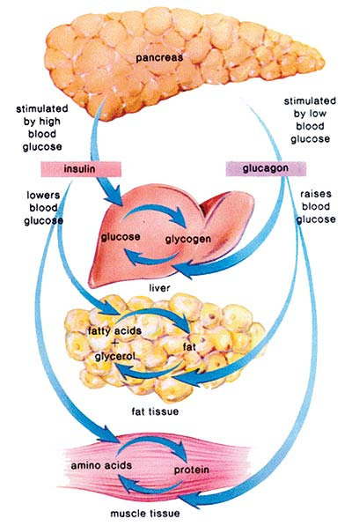
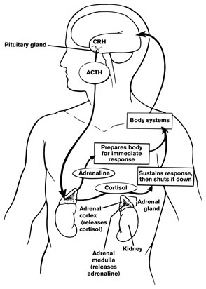
http://www.youtube.com/watch?v=NnIWDxuZKUo Cortex – hormonal control – _________________ Medulla – nervous control – ___________________

