**VIRTUAL Fetal Pig Dissection**

**BACKGROUND:**

Mammals are vertebrates having **hair** on their body and **mammary glands** to nourish their young. The majority are **placental mammals** in which the developing young, or **fetus**, grows inside the female's **uterus** while attached to a membrane called the **placenta**. The placenta is the source of food and oxygen for the fetus, and it also serves to get rid of fetal wastes. The dissection of the fetal pig in the laboratory is important because pigs and humans have the same level of metabolism and have similar organs and systems. Also, fetal pigs are a byproduct of the pork food industry so they aren't raised for dissection purposes, and they are relatively inexpensive.

**OBJECTIVES:**

* Identify important external structures of the fetal pig.
* Identify major structures associated with a fetal pig's digestive, respiratory, circulatory, urogenital, & nervous systems.
* Compare the functions of certain organs in a fetal mammal with those of an adult mammal.

**PROCEDURE:**Go the following URL: http:// [www.whitman.edu/content/virtualpig](http://www.whitman.edu/content/virtualpig)

***Anatomical References -*** *Click on “Anatomical References”*

1. Draw a sketch of a fetal pig below. Label the dorsal, ventral, and lateral surfaces.

*Click on “Regions of the Pig”, “Anterior/Posterior” “Medial/Lateral” “Dorsal/Ventral” and “Proximal/Distal” to help you label the different areas.*

|  |
| --- |
|  |

1. Explain the difference between anterior and posterior:

|  |  |
| --- | --- |
| anterior | posterior |
|  |  |

1. Explain the difference between dorsal and ventral:

|  |  |
| --- | --- |
| dorsal | ventral |
|  |  |

**Sexing Your Pig –** Click on “Sexing your pig”.

1. Explain how to externally tell a male and female fetal pigs apart:

|  |  |
| --- | --- |
| male | female |
|  |  |

**Digestive System**

*Click on “digestive system”. Go through the virtual dissection. While you are going through the virtual dissection, label the diagram of the internal anatomy and answer the questions below.*

1. **The Head:** Write down what each organ is and what it does
   1. Salivary Gland:
   2. Pharynx:
2. **The Abdominal Cavity:** Write down what each organ is and what it does:

Peritoneal Membrane:

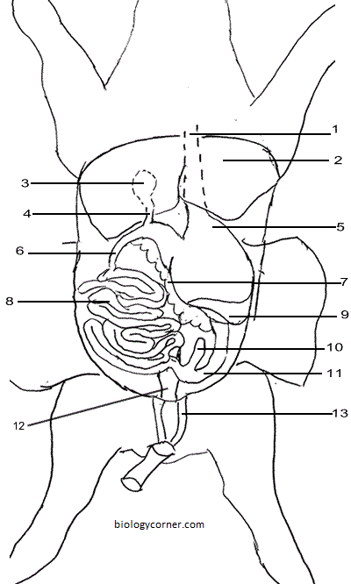

Gall Bladder:

Pyloric Sphincter:

Pancreas:

Umbilical Arteries:

Mesentery:

**Excretory System:**

*Click on “excretory system”. Go through the virtual dissection, answering the questions below as you do so.*

1. What is excretion?
2. In the area beow, sketch a diagram of the urinary system. Include and label the following organs:

***Kidneys, Renal Blood Vessels (Renal Veins/Renal Arteries, Ureters, Bladder***

|  |
| --- |
|  |

**Circulatory System**

*Click on “circulatory system”. Go through the virtual dissection, answering the questions below as you do so.*

1. What is the circulatory system responsible for?
2. Using colored pencils, color in the different parts of the diagram using red (blood carrying oxygen) and blue (blood carrying carbon dioxide, little oxygen). Do not confuse the color blue with what the color of deoxygenated (low oxygen) blood is. It isn’t blue. It’s a very deep red.



**Reproductive System**

*Click on “reproductive system”. Go through the virtual dissection, answering the questions below as you do so.*

1. In the area below, sketch a diagram of the female and male reproductive systems. Include and label the following organs:
2. **Female: Male:**
   1. a. Ovaries a. Penis
   2. b. Oviducts b. Testicles
   3. c. Uterus c. Epididymae

|  |  |
| --- | --- |
| Female | Male |
|  |  |

**Respiratory System**

*Click on “respiratory system”. Go through the virtual dissection, answering the questions below as you do so.*

1. What is the respiratory system?

**Nervous System**

*Click on “nervous system”. Go through the virtual dissection, answering the questions below as you do so.*

1. What is the layer of tissue that covers the brain called?
2. What are the four sections of the brain and what are they in control of?

**Reflection:**

What did you enjoy most about the virtual fetal pig dissection? What parts were surprising/unexpected? What was the most difficult part?