Intro to the Local Diseases Project: Name: _______________________________
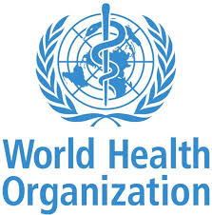
Go to the following webpage on the World Health Organization WHO website: http://bit.ly/diseaseoutbreakbyyear
Click on 2019
- Summarize where most outbreaks have taken place.

- What disease do you see most commonly?

- Choose one disease outbreak to learn a bit more about (it can be from 2019 or 2018).

  - Name of disease: _________________________
  - Where was the outbreak: ____________________
  - How many people were affected? – How many people were sick vs. how many died?

  - How did it start? Where did it come from?

  - WHO Risk assessment – 3 main things you learned from that section

  - WHO Advice – 2 pieces of advice from this section

NEXT:

If your job was to educate others about the disease:
- To warn them of the dangers
- To prevent them from getting it

What type of information would you need to find out about the disease and then include in your presentation to a group of at risk people?

