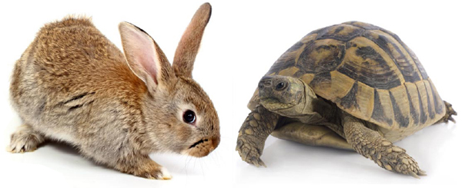
Introduction to Motion-The Hare and the Tortoise Part I

- Watch the video at http://www.youtube.com/watch?v=pjokVI0LJzw
- While watching, generate a list of “physics” terms you think could be used to describe the motion occurring within the story. Post those terms on the Twiducate discussion.

- Share your list with a partner and add any new terms you think might be useful.
- Complete the terminology assignment on the 2nd page of this package.
- Watch the video again and use the newly learned physics vocabulary to describe the motion occurring in the story.

- Compare your description with a partner. Did you both use the correct terminology?

Motion Terminology Matching (Physics Chapter 12)
Match the terms in the vocabulary box with their descriptions below. Each term can only be used once.
average velocity position-time Graph time
distance (displacement-time graph) time interval
displacement positive slope uniform motion
magnitude scalar velocity
negative Slope vector zero slope
position speed slope

Term | Definition
A. | 1. A value that has only magnitude, not direction.
B. | 2. A measurement or value that has both magnitude and direction.
C. | 3. A scalar that describes the length of the path between two points. (Δd)
D. | 4. The distance and direction of a straight line between two points (Δd).
E. | 5. A vector that describe a specific point relative to a reference point. (d)
F. | 6. When an event occurs. (t)
G. | 7. The time difference between two events. (Δt)
H. | 8. Motion that is constant in both direction and speed.
I. | 9. Change in y-axis over change in x-axis.
J. | 10.
K. | 11.
L. | 12.
M. | 13. A scalar quantity of the distance moved per unit of time.
N. | 14. A vector quantity of the direction and displacement moved per unit time (Δv)
O. | 15. A measurement of an amount or quantity.
P. | 16. A graphic representation of the motion of objects. Can be used to determine velocity.
Q. | 17. The velocity of an object over a given time interval. (Δv_{av})

