Know your genome: what we can all gain from personal genetics
Anne Wojcicki
Discovering your DNA sequence is cheap and easy, and that genetic knowledge could change – even save – your life
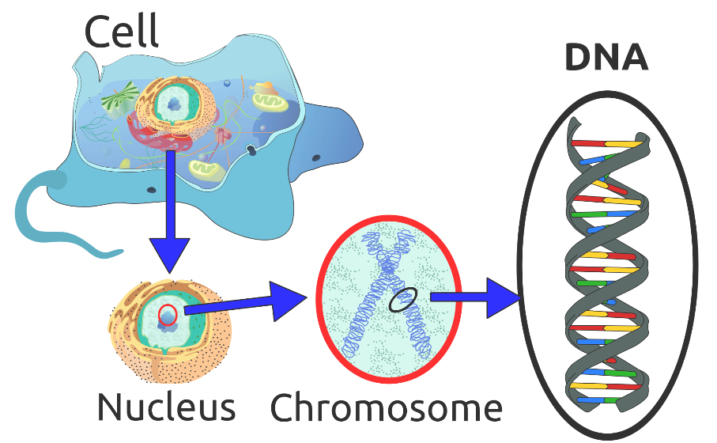
Wednesday 13 March 2013
A decade ago, researchers completed what was one of the greatest scientific achievements of our time when they decoded the last of the three billion letters that make up the human genome. Since then, the cost of sequencing has dropped dramatically – from $3bn for the first human genome to a few thousand dollars today.
Inexpensive sequencing created a whole new industry, enabling individuals to access their own genetic information. You may never have thought about what's in your genome, but one day soon you will, and it will be an important part of your healthcare.
Far sooner than anyone would have thought possible, the real-world benefits of genetic science and access to the data itself are available to people the world over. Today, genetics is not just for scientists. Each of us can now explore our own DNA. I co-founded the personal genetics testing company 23andMe in 2006 with the mission of enabling people to get access to their DNA and create the software tools so they can understand it.
I am asked regularly, "Why would you ever want your genetic information?"
Learning about your genetics enables you to optimize your health. It will take us decades to understand all 3bn base pairs in the human genome, but today we already know what thousands of important genetic differences mean for individuals.
We know that genes affect your risk for conditions like cystic fibrosis and breast cancer, and we know how your genes affect your responses to drugs like Warfarin. As genetic testing becomes more affordable, more people can benefit from understanding their genetics and use that understanding to improve their health, help them prevent the harmful side-effects of some drugs and potentially avoid preventable deaths.
For example, roughly 8% of people with European ancestry have a genetic variant that puts them at higher than average risk for blood clots. There are a number of easy ways to minimize this risk, ranging from avoiding oral contraceptives to staying hydrated and maintaining mobility during airplane flights.
A decade ago, NBC journalist David Bloom died at the age of 39 on assignment in Iraq after spending many hours with limited mobility in a tank. Bloom's wife has said he didn't know he was genetically predisposed to blood clots. If he had known, could he have changed his fate? It's easy to get tested for this genetic variant and it enables those individuals with high risk to make changes in their lifestyle that decrease their risk.
Some genetic variants can be informative about one's risk for Parkinson's disease and Alzheimer's disease. While effective medical interventions might not exist today to reverse those diseases, individuals might opt to make choices based on that knowledge – have children earlier, or retire sooner. The knowledge might also spur lifestyle changes that could help mitigate the effects or stave off the onset of those diseases. My husband found out he is genetically at a higher risk for Parkinson's disease. That information motivated him to exercise more, moderate his diet and drink coffee – choices that research shows could decrease his risk.
Learning of his genetic risk for Parkinson's also motivated my husband to participate in research. There is now a community of more than 700 individuals who have the same rare genetic variant that puts them at a higher risk for Parkinson's disease. Partnering with researchers this community is trying to answer a number of important questions: why do some people get the disease and some don't? What environmental factors might contribute to, or possibly help prevent, the disease? What treatments work best? Combining genetic data with the efficiency, scalability and global information exchange enabled by the internet has opened up a whole new world to researchers.
The next decade will bring about tremendous discovery and alter the way we approach healthcare. Prime Minister David Cameron's administration recently announced plans to spend £100m to sequence 100,000 people and create a national human genome database. This database alone will trigger tremendous understanding of the genome and fuel medical innovation.
The genetic revolution is here. Just as computer technology and the internet created whole new industries and extraordinary benefits for people that extend into almost every realm of human endeavor from education to transportation to medicine, genetics will undoubtedly benefit people everywhere in ways we can't even imagine but know will surely occur.
Summarize the main points:

What questions does this article raise for you?

What more do you need to know?

