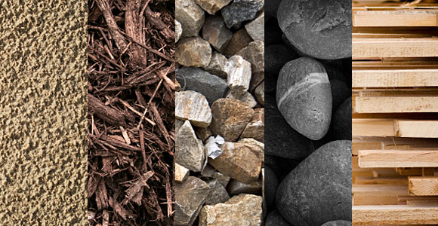
Thinking/Pondering phase:
- What “objects/things” do you interact with on a daily basis?

- What “objects/things” help you do a task in your life?

- What “objects/things” make your life easier?

- What “objects/things” have you always wondered about?

Choosing your Object:
- What “object/thing” are you going to investigate more deeply? ____________________________

  - Why?

Investigate your object further:
- How has the way that your “object/thing” is designed changed or improved over time?

- What materials have allowed for recent updates to your “object/thing’s” design?

Choosing & Investigating your Material:

- Which of those materials will you focus on for this project? ___________________

  - Why?

- What are the properties of your material? - typical state of matter, melting point, boiling point, strength, hardness, reflective qualities, conductivity, density etc.

- How is your material made? Where does it come from?

- How does your material function in your “object/thing”?

- How does your material improve your “object/thing” compared to previous models/designs? How do its properties relate to its use in the object/thing?

- What are the implications of using your material in your “object/thing”?

  - What are advantages of using this material in your “object/thing”? Relate to at least one of the following factors: Social, Economic, Environmental

  - What are disadvantages/limitations of using this material your “object/thing? Relate to at least one of the following factors: Social, Economic, Environmental

BIBLIOGRAPHY
Web site title | Web page Title | URL

ASSESSMENT
Criterion D: Reflecting on the Impacts of a Material
(0) | Beginning (1-2) | Developing (3-4) | Accomplished (5-6) | Exemplary (7-8)
I have not achieved a standard described to the right. | I am able to:  state the ways in which a material is used to address a specific problem or issue  state the implications of the use of a material to solve a specific problem or issue, interacting with a factor  apply scientific language to communicate understanding but does so with limited success  document sources, with limited success. | I am able to:  outline the ways in which a material is used to address a specific problem or issue  outline the implications of using a material to solve a specific problem or issue, interacting with a factor  sometimes apply scientific language to communicate understanding  sometimes document sources correctly. | I am able to:  summarize the ways in which a material is applied and used to address a specific problem or issue  describe the implications of using a material and its application to solve a specific problem or issue, interacting with a factor  usually apply scientific language to communicate understanding clearly and precisely  usually document sources correctly. | I am able to:  describe the ways in which a material is applied and used to address a specific problem or issue  discuss and analyse the implications of using a material and its application to solve a specific problem or issue, interacting with a factor  consistently apply scientific language to communicate understanding clearly and precisely  document sources completely.

Command Terms for Science
Analyse - Break down in order to bring out the essential elements or structure. To identify parts and relationships, and to interpret
information to reach conclusions.
Apply - Use knowledge and understanding in response to a given situation or real circumstances
Describe - Give a detailed account or picture of a situation, event, pattern or process
Discuss - Offer a considered and balanced review that includes a range of arguments, factors or hypotheses. Opinions or conclusions
should be presented clearly and supported by appropriate evidence
Outline - Give a brief account
State - Give a specific name, value or other brief answer without explanation or calculation
Summarize - Abstract a general theme or major point(s)

