Mutations – Notes Name: ________________________
Definition: A _____________ in the sequence of bases within the DNA.
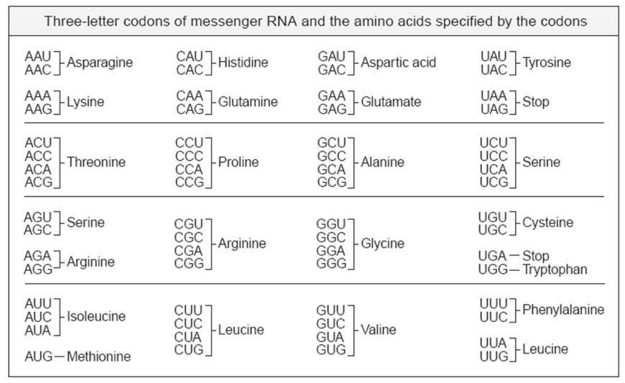
2 types:
- Frameshift: One or more nucleotides is ___________________from the DNA
Example: TAC GGT TAG, insert C into the 4th spot:
TAC CGG TTA G
The original DNA coded for which amino acids?
- DNA: TAC GGT TAG
- mRNA:
- amino acids:

The mutated DNA now codes for which amino acids?
- DNA: TAC CGG TTA G
- mRNA:
- animo acids:

- Point Mutations: __________________________within the sequence

Example: TAC CCA,GAC replace 2nd A with a C
TAC CCC,GAC
The original DNA coded for which amino acids?
    - DNA TAC CCA,GAC
    - mRNA:
    - amino acids:
The mutated DNA now codes for which amino acids?
    - DNA: TAC CCC,GAC
    - mRNA:
    - animo acids:

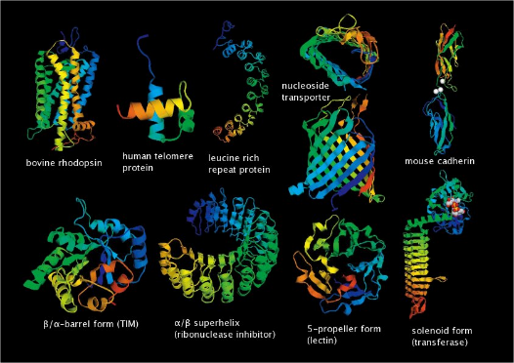
Questions:
- What effect does changing the amino acids have on the protein product?
  - Changes _____________. Since shape determines ______________, it alters how the protein will function.
  - Example __________________
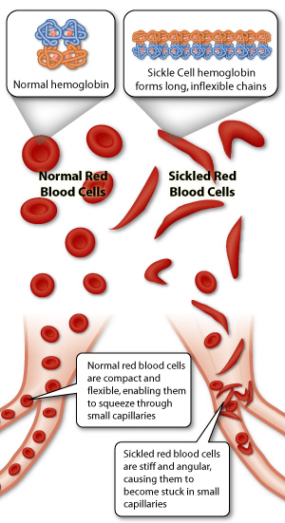
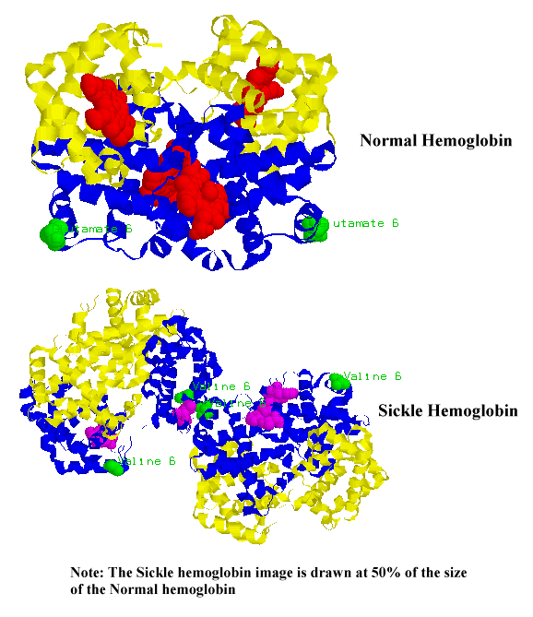
  - What type of mutation is it? _____________________
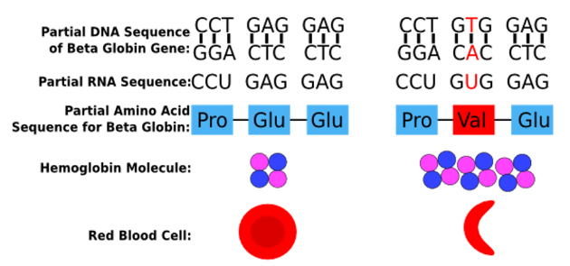

- Which has the potential for the most damage, frameshift mutations or point mutations? And why?

Mutagens
  - Definition:__________________ influences that cause mutations

  - Brainstorm a list:

  - Here are some examples:

