Science 8 - The Atom – notes Name: ____________________
Draw a model of an Atom:
Particle | Location | Charge | Mass
Proton
Neutron
Electron

Inquiry Activity:
- Take a package of 20 elements.

- As a group decide how to put them in order.

- Once they are in order - find a property that allows you to divide them into 4 groups.

- Show me once you feel you have solved the puzzle

Questions to answer about 20 elements:
- What happens to the number of protons as you move from smallest to biggest?

- What happens to the number of neutrons as you move from smallest to biggest?

- Are the number of protons and neutrons always the same?

- What happens to the number of electrons as you move from smallest to biggest?

- Which particles are found in the nucleus?

- Which particle in the nucleus always has the same amount as the number of electrons?
Orbitals:
- Describe how are the electrons organized?

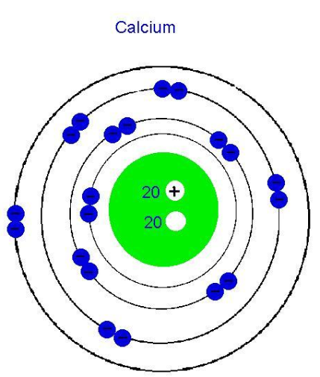
- What is the maximum number of electrons found in each orbit?

Orbit | Max # of Electrons
1
2
3
4

- Relate this organization to the four groups that you made?

