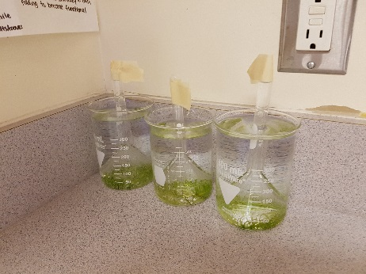
Let’s reflect on the experiment that we conducted together:

Analyze the Data:
Describe the results and what they mean (use scientific reasoning)

Overall, what does the data tell you (what can you conclude)?

Validity of the Method
- Positive Qualities

- Possible Issues

Improvement
- How could we change the lab to make it more valid?

