Protein Synthesis – Notes Name: _______________________

What are the 2 stages of Protein Synthesis?
Using the diagram on below to answer the following:
 | Transcription | Translation
Location?
What is made?
What things are involved? (list as many as you can)

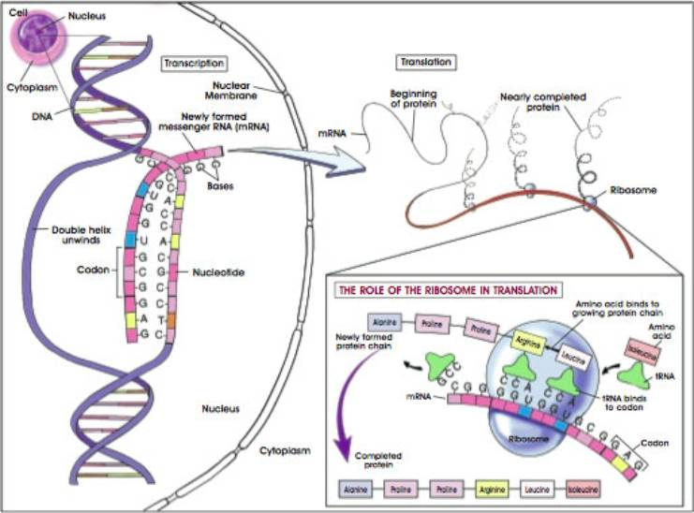

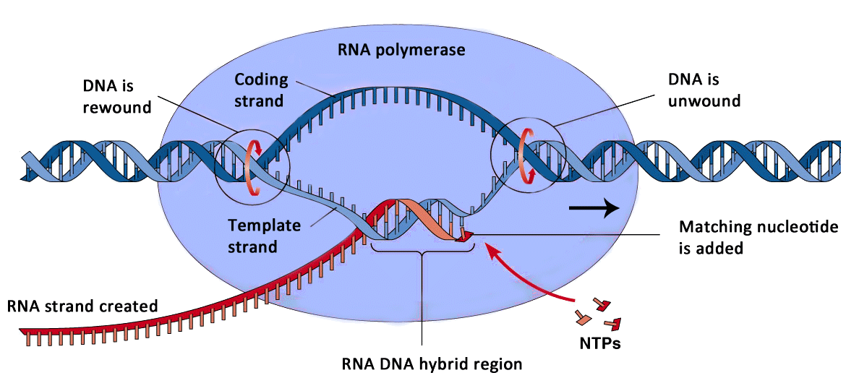
Part 1: Transcription
Where does it occur? In the ________
DNA is used as a ________ to form a molecule of single-stranded _______ (___________RNA)

What are the 3 parts of Transcription?
- Initiation
  - One section of DNA is ___________ (Hydrogen bond between nitrogen bases are _____________)
- Elongation
  - _____________ ribo-nucleotides ___________ hydrogen bond with their _____________ nucleotides on the DNA template
  - Only _____of the DNA strands is used as the template.
  - Ex: DNA – A T C G
RNA – ________
- Termination
  - RNA polymerase reaches ________________
  - RNA polymerase _____________ from DNA, releasing ______________ mRNA strand
  - DNA ___________ into its double helix
  - mRNA is transported ________ of the nucleus

