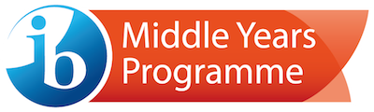
MYP Science 8 (Year 3)
Course Outline 2017-2018

Teacher: Mrs. Towers
Email: jtowers@wvschools.ca

Introduction:

Welcome to Science 8! In this course you will get the opportunity to develop scientific knowledge, skills, and attitudes that will be relevant in your everyday life. Together, we will investigate scientific questions while building on your sense of wonder and curiosity about the world. Throughout the course every effort will be made to show how Science connects to other areas of study.

You will be encouraged to communicate your ideas and consider the thoughts and opinions of others. You will also work to develop yourself as communicating, caring, inquiring, risk taking, knowledgeable, reflective, open-minded, principled, balanced, and thinking individual.

Aims and Objectives:

This course meets the Prescribed Learning Outcomes set out by the BC Ministry of Education and the MYP aims and objectives as described by the International Baccalaureate Organization.
The aims for this course are to:
- understand and appreciate science and its implications
- consider science as a human endeavor with benefits and limitations
- cultivate analytical, inquiring and flexible minds that pose questions, solve problems, construct explanations and judge arguments
- develop skills to design and perform investigations, evaluate evidence and reach conclusions
- build an awareness of the need to effectively collaborate and communicate
- apply language skills and knowledge in a variety of real-life contexts
- develop sensitivity towards the living and non-living environments
- reflect on learning experiences and make informed choices

The objectives of this course are:

A: Knowing and Understanding – students should be able to:
- describe scientific knowledge
- apply scientific knowledge and understanding to solve problems set in familiar and unfamiliar situations
- analyze information to make scientifically supported judgment

B: Inquiring and Designing – students should be able to:
- describe a problem or research question to be tested by a scientific investigation
- outline a testable hypothesis and explain it using scientific reasoning
- describe how to manipulate the variables, and describe how data will be collected
- design scientific investigations

C: Processing and Evaluating – students should be able to:
- present collected and transformed data
- interpret data and explain results using scientific reasoning
- discuss the validity of a hypothesis based on the outcome of the scientific investigation
- discuss the validity of the method
- describe improvements or extensions to the method

D: Reflecting on the Impacts of Science – students should be able to:
- describe the ways in which science is applied and used to address a specific problem or issue
- discuss and analyze the various implications of the use of science and its application in solving a specific problem or issue
- apply scientific language effectively
- document the work of others and sources of information used

Approaches to Learning:

Throughout this course, we will be using various approaches to learning, these include:
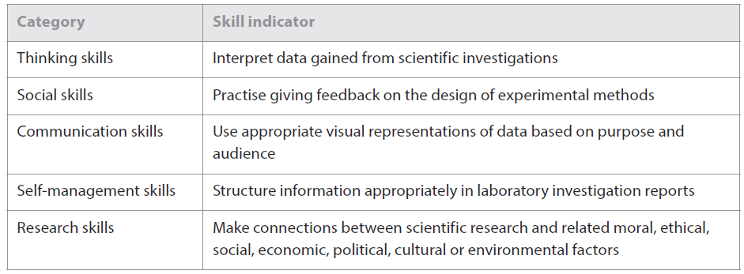

Concept Based Learning through Global Contexts:

MYP inquiry recognizes the integrity of subject disciplines, but learning is richer and deeper when conceptually driven. Building a deep understanding requires meaningful reflection. MYP uses the Global Contexts to drive inquiry. The statement of Inquiry derived from the global contexts and key/related concepts for each unit are listed below along with the assessment task and corresponding criteria for each term:

Unit Title | Statement of Inquiry | Assessment Tasks | Criteria Assessed
Term 1
KMT, Density and atomic theory | Models can demonstrate observable patterns in systems such as KMT, Density and Atomic Theory.  Everyday objects often have complex evolutions due to the advanced properties of newly available materials. | Quizzes and Unit Test | A
 |  | Bounty Design Lab  Properties of Water lab | B and C + Self-Management ATLs
 |  | Material Matters Report | D
Term 2
Electromagnetic radiation and Optics | The relationship between form and function can lead to ingenious transformations. | Quizzes and Unit Test | A
 |  | Properties of Light | C
 |  | Radical Radiation Report & Presentation | D + Communication ATLs
Term 3
Cell Biology and Immunology | Cells/Micro-organisms consist of and are part of complex systems in which form is related to function that ultimately have both positive and negative consequences. | Photosynthesis Design lab | B (for term 2)
 |  | Quizzes and Test | A
Preparation for Outdoor School | When people interact with the environment there are consequences to their health and well- being. | Northwest Disease research and presentation | Communication and Social ATLs
Plate tectonics | Evidence of scale, duration, frequency and variability can change behaviour. | Earthquake Preparedness research and presentation | D + Communication & Social ATLs
Year-end unit | Systems are necessary to provide structure and order when it comes to form and function in order to avoid inequalities. | Bogus Brands Design Lab | B and C

Texts/Resources and Required Materials:
- Section of a 3-ring binder – with a divider
- Paper
- Your device
- Agenda book to record homework, due dates and exam dates
- Pens (various colours), pencils, ruler
Methods of assessment:

Formative Assessment: Students will have frequent quizzes and complete rough drafts of assignments to demonstrate what they understand versus what they still need help with. Students will also have class work and homework that they will correct with classmates and the teacher. Students will be encouraged to discuss their thinking about the various problems and topics covered in class.

Summative Assessment: At the end of each unit and at the end of the course students will write tests or exams. Students will also partake in individual and group projects and do self-assessments of their learning. Students will be required to demonstrate their knowledge, their understanding, applications of skills and concepts in a manner that is clear and organized in all the above mentioned forms of summative assessment.

All grading will be based on MYP assessment rubrics (attached) and BC Prescribed Learning Outcomes: https://curriculum.gov.bc.ca/curriculum/science/8

MYP Assessment Rubrics:

Criterion A: Knowing and Understanding (used to assess tests and quizzes)

Criterion B: Inquiring and Designing (used to assess laboratory investigations)

Criterion C: Processing and Evaluating (used to assess laboratory investigations)

Criterion D: Reflecting on the Impacts of Science (used to assess projects, essays or presentations)

In Science, your work is assessed on an 8 point scale. This is not a score “out of 8”, therefore a result
of 4/8 does not equate to 50% but is closer to a 70%.
MYP Grade | Approximate Letter Grade
8 | A+ | Exceeds expectations
7 | A | Excellent work
6 | A-/B+ | Very good work
5 | B | Good work
4 | B-/C+ | Decent effort, Satisfactory work
3 | C | Satisfactory work
2 | C/C- | Meets minimal standards, all work is being completed
1 | C-/I | Insufficient effort, but work is usually completed
0 | I | Work is not being completed/No effort
All marks are cumulative. Students must show continuous growth from September through June. Though a student may start with a 1 or 2 does not mean they cannot achieve a higher MYP level by the end of the year.

The final mark is not an average of all three terms. Current level of progress or trending results are used to report level of achievement. Therefore, always try your best and don’t give up!

IB Criterion total /32 | IB grade | Approximate Letter grade
1-5 | 1 | F
6-9 | 2 | F/C-
10-14 | 3 | C-/C/C+
15-18 | 4 | C+/B
19-23 | 5 | B/A
24-27 | 6 | A
28-32 | 7 | A+
For the term 3 report card, each student will receive a FINAL IB grade (1-7) for each subject. That is determined by adding the most recent and consistent achievement level on each of the 4 criteria together and then using the chart to the right to make the conversion.

The descriptors for each IB Final Grade from 1 (lowest) to 7 (highest) are explained on the next page. These descriptors reflect the objectives of the eight subject areas. All of the IB MYP subject criteria, along with the Rockridge Assessment Policy, can be found on the MYP page of our school website.

IB Final Grade | Descriptor
1 | Produces work of very limited quality. Conveys many significant misunderstandings or lacks understanding of most concepts and contexts. Very rarely demonstrates critical or creative thinking. Vary rarely applies knowledge or skills.
2 | Produces work of limited quality. Expresses misunderstandings or significant gaps in understanding for many concepts and contexts. Infrequently demonstrates critical or creative thinking. Infrequently applies knowledge and skills.
3 | Produces work of an acceptable quality. Communicates basic understanding of many concepts and contexts, with occasionally significant misunderstandings or gaps. Begins to demonstrate some basic critical and creative thinking. Occasionally applies knowledge and skills, requiring support even in familiar classroom situations.
4 | Produces good-quality work. Communicates basic understanding of most concepts and contexts with few misunderstandings and minor gaps. Often demonstrates basic critical and creative thinking. Applies knowledge and skills in familiar classroom situations, but requires support in unfamiliar situations.
5 | Produces generally high-quality work. Communicates secure understanding of concepts and contexts. Demonstrates critical and creative thinking, sometimes with sophistication. Applies knowledge and skills in familiar classroom and real-world situations and, with support, some unfamiliar real-world situations.
6 | Produces high-quality, occasionally innovative work. Communicates extensive understanding of concepts and contexts. Demonstrates critical and creative thinking, frequently with sophistication. Applies knowledge and skills in familiar and unfamiliar classroom and real-world situations, often with independence.
7 | Produces high-quality, frequently innovative work. Communicates comprehensive, nuanced understanding of concepts and contexts. Consistently demonstrates sophisticated critical and creative thinking. Frequently applies knowledge and skills with independence and expertise in a variety of complex classroom and real-world situations.

Policies and Procedures:
Students in Grade 8 science will work to develop their Self-Management skills within a High School setting. This is easy for some and challenging for others. These Policies and Procedures reflect my desire for my students to learn and grow in the area of Self- Management:
Supplies: Bring all necessary classroom supplies (especially a charged internet connected device) to class every day.
Homework: Homework will be marked daily for completion. Incomplete homework will affect your ATL – Self Management mark.
Be on time: It is expected that at the second bell you are in your seat and ready to start the opening activity with your device open, logged in and connected to the internet. Lateness will also impact your Self management mark.
Deadlines: It is expected that you hand in your completed assignments by the due date at the beginning of class. Late assignments collected up to the following class will be marked as late but will receive full assessment. If special extensions are needed, please ask well in advance of the due date. Rough draft deadlines are optional but if met will lead to better achievement on the final product.
Absences: All absences from the class must be excused by a phone call to the office on the day you are absent (call 981-1300 before 8:25 a.m.). You are responsible for getting caught up with the material you missed – all information is found on my website: http://mrstowers.weebly.com/. If you can’t find the missed work on the website – ask a friend or email me. If you arrive to class following an absence without having caught up- this will affect your Self-Management mark.
Checkpoints/Tests: After each topic a checkpoint will be written. These quizzes will be marked and recorded for Criteria A. You will have the opportunity to improve your level for Criteria A on the unit test.
Assessment: You will be expected to take an active role in assessment and be responsible for your own learning. With the help of your teacher and your peers, you will develop the ability to understand what you have already learned, determine what you have yet to learn, and decide how you can best improve on your achievement. We will assess all concepts, assignments and labs using MYP – Criterion related rubrics - that have clear criteria.
Missed Tests: Should you have an excused absence from a test, you will write it shortly after – make arrangements with me. Note: no make-up tests will be written unless an email is sent in advance by the student and a follow-up note/email is sent from home.
How can you get extra help? Arrange an appointment with me – meet in W205

Anything Else? If you have any questions or concerns, please do not hesitate to talk to me during class or email me from home. I am looking forward to a fun and exciting year of Science 8!!

