2013 Science 10 Enriched Science Fair

Date: May 31st - after school in W204

Purpose: To utilise knowledge learned from all aspects of Science 10, Science 10 Enriched, and other mediums to create a comprehensive project regarding one subject matter.

What you'll be doing:

Using a tri-fold display board, you will in partners or alone create an informative display that shows off a unique (no baking soda & vinegar volcanoes please!) scientific experiment to share with your classmates, as well as other students in the school. Feel free to use models, multimedia, or other forms of communication to inform and wow visitors and judges.

Your experiment needs to include:
- A problem
- Independent, dependent and control variables
- Hypothesis
- Materials
- Procedures
- Observations - data, graphs, pictures
- Conclusion

Suggestions for possible experiments:

- Does location or color of sugar water have more effect on the hummingbird feeder use?
- How does wrapping and location of food products affect their “freshness” over the long term?
- How does gender, race and family relationship relate to fingerprint patterns?
- Does location of the market effect grocery prices?
- Does the traffic quantity change on Headland drive at different times during the day?
- Does the type of music played during an art activity affect the drawing of a picture?
- Do most brands of the same size jean measure the same?
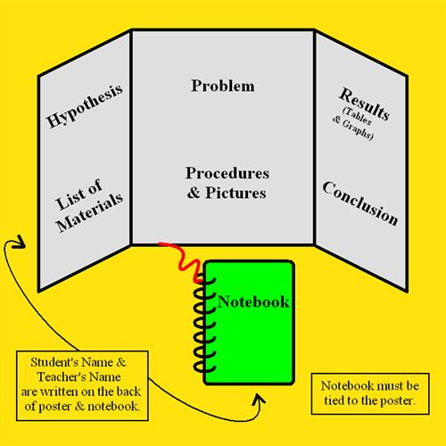
- Do supermarkets with club cards offer better savings than supermarkets without cards?
- Do more boys are girls spend more time on their phones texting?
- Do the gas prices decrease with distance from the freeway?
These are just suggestions to get your started. Brainstorm your own ideas.

During and after the research and execution of your project you will be tasked with responding to several questions sent to you via email (similar to last unit's spontaneous homework questions). These questions will be focused on your project's topic, and your personal progress through the assignment. Each set of questions will be sent on Thursday afternoon and will be due the following Sunday at 11:59PM.

How you'll be assessed:
- The responses given to the progress questions given to you throughout the course of the project and will be graded on a 3 point scale:
0 marks - No/Insufficient Response
1 mark - Satisfactory Response
- marks - Full Response
- The responses to the questions asked on the day of the fair. Be prepared to explain what you did in your experiment, the results and what you learned. Further details revolving around response marking is included in the rubric attached. These will also be graded on a three point scale:
0 marks - no answer
1 marks - simple answer, gaps in understanding, not clear
2 marks - full complete in depth understanding of the material.

IMPORTANT DATES
- Thursday, May 9th - The first response questions will be sent. These questions will most likely revolve around your chosen topic.
- Thursday, May 9th → Sunday, May 12th - Your topics will be checked to see if they are viable. If they are not, you will be told why and you will be asked to submit a new topic. Your topic should be finalized by the end of this time period.
- May 31st - Science Fair!

Assessment for the Poster board

Criterion | Beginning | Developing | Accomplished | Exemplary
Scientific Method  - problem  -variables  -hypothesis  -materials  -procedure  -observations | - Did not follow the scientific  Method  - The problem and hypothesis have a predictable explanation  - Most variables are not  identified  - The data is poorly presented and poorly analyzed. | - Minimal use of scientific  method.  - The problem and  hypothesis are lacking  scientific thinking.  - Some variables are  identified and controlled.  - The data is presented and  analyzed. | - Attempted to follow the  scientific method  - The problem and hypothesis are somewhat indicative of scientific thinking.  - Most variables are identified and controlled.  - The data is presented and  analyzed. | - Clearly followed the scientific method in order to perform the experiment.  - The problem and hypothesis are indicative of scientific thinking.  - All variables are identified and controlled.  - The data is well presented and analyzed.
Conclusion | - No scientific concepts are  explained, nor have been  learned. | -Some brief explanation  revealing that something  was learned. | - Good explanation about the science that was learned. | - Excellent explanation about  what was discovered, which may be used to pursue new question for a possible explanation.
Display | - May/may not be a self-standing press board  - Unattractive  - Messy  - Unclear  - Some titles are labeled | - May/may not be a self-standing press board  - Very plain, not very  attractive, somewhat neat  -Unclear  -Titles are labeled | -Self-standing press board  - Basic and plain, yet attractive and neat.  - In need of clarification  - Relatively logical flow  -Titles are clearly labeled | -Self-standing press board  - Neat, colorful, graphics, tables, charts, photographs, etc.  -Self-explanatory.  -Flows logically  -Titles are clearly labeled

