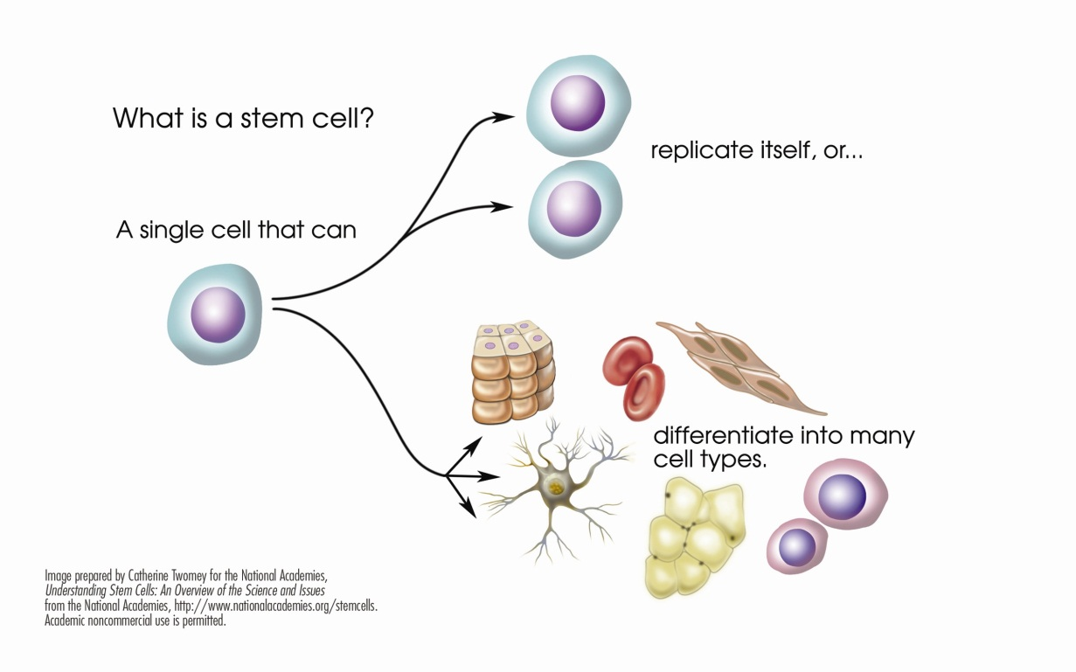
Specialized Human Cells

The body is composed of many different types of cells, each with its own structure and function. Some, such as white blood cells, move freely, unattached to other cells. Others, such as muscle cells, are firmly attached one to another. Some cells, such as skin cells, divide and reproduce quickly. Others, such as nerve cells, do not divide or reproduce except under usual circumstances. Some cells, especially glandular cells, have as their primary function the production of complex substances, such as a hormone or an enzyme. For example, some cells in the breast produce milk, some in the pancreas produce insulin, some in the lining of the lungs produce mucus, and some in the mouth produce saliva. Other cells have primary functions that are not related to the production of substances—for example, muscle cells contract, allowing movement. Nerve cells generate and conduct electrical impulses, allowing communication between the central nervous system (brain and spinal cord) and the rest of the body.
http://www.merckmanuals.com/home/fundamentals/the_human_body/cells.html
RED BLOOD CELLS, for instance, have disklike flattened membranes. This shape gives them a maximum amount of surface area while still remaining smooth enough to slide through the smallest capillaries. Because red blood cells are manufactured for limited-time use, they have lost nearly all of their internal organelles, including nuclei.
NERVE CELLS are responsible for the rapid conduction of messages throughout the body. Consequently, they are very long and have branches that enable them to connect to other nerve cells.
GLAND CELLS, like the cells found in the pancreas, are filled with Golgi apparati. And muscle cells, which must generate large amounts of force, have huge mitochondria and many microfibers.
http://www.beyondbooks.com/lif71/4h.asp

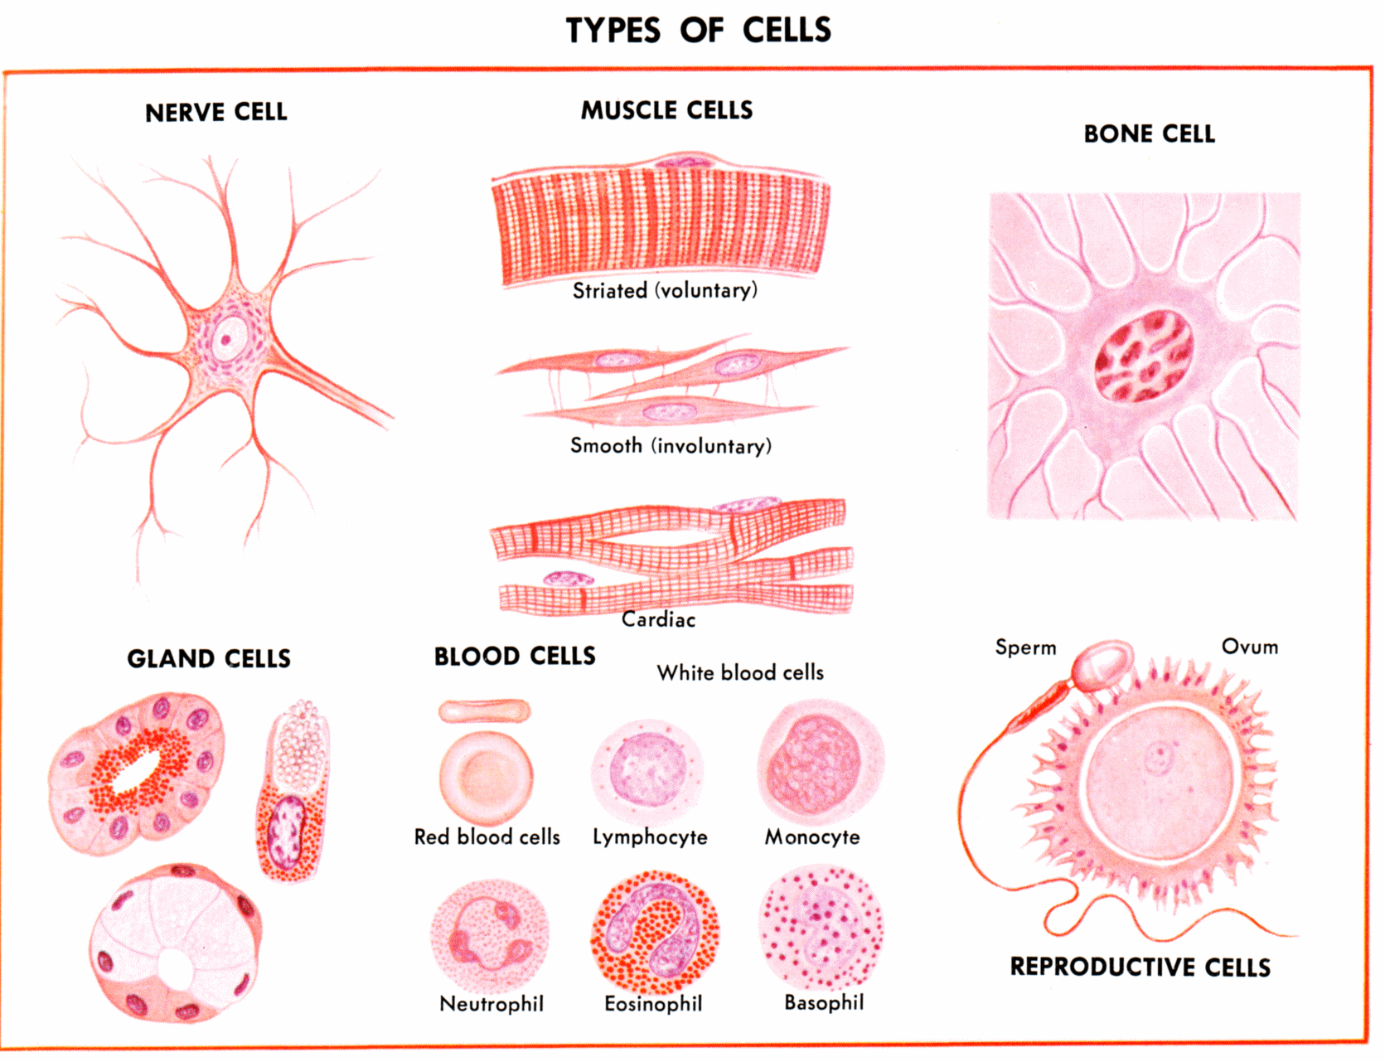
With Animal Cells we look at the specialized function of different cell types and what they do in the body. These specialized functions are reflected in special proteins and organelles - sometimes just found in greater numbers than found in other animal cells.
For example, the heart cell is a muscle cell and therefore contains specialized proteins called 'actin' and 'myosin'. These proteins are arranged in fibers that slide back and forth so that the full length of the fibers are either long (relaxed) or short (contracted). It takes energy in the form of ATP to do the work of contraction and therefore muscle cells have a high number of mitochondria. Mitochondria are the organelles that make ATP for use in cells as an energy source. They make ATP by breaking down sugar into CO₂.
Another specialized cell is the white blood cell which is necessary for killing bacteria that get into the body - also known as an 'infection'. These cells have a super abundance of plasma membrane. While not usually thought of as an organelle, the plasma membrane is an amazingly complex and highly functional part of any cell. In the case of white blood cells, the plasma membrane contains the proteins that recognize bacteria. These specialized proteins are able to track down the bacteria, make the white blood cell actually move to the bacteria, and then engulf the bacteria. Other specialized organelles – such as lysosomes then fuse with the plasma membrane and dump highly toxic enzymes right up next to the bacteria so they will be killed.
http://www.eurekascience.com/ICanDoThat/animal_cells_pt.htm

