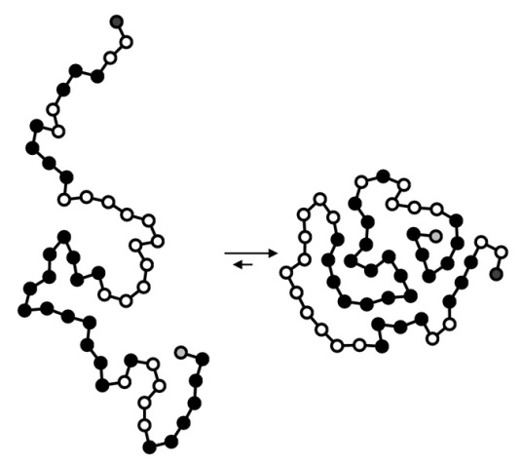
Review This This’s - Enzymes
- Where are enzymes made? What are they made of?

- When an enzyme denatures – what actually happens at the chemical level?
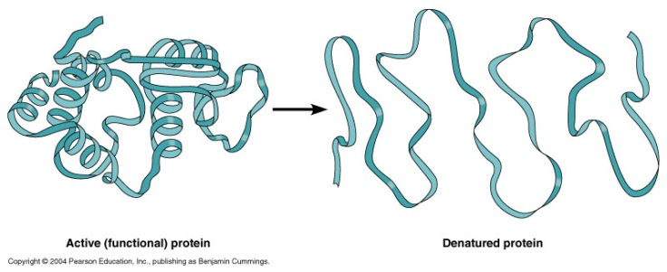
Connections to the Catalase lab:
- In the experiment from last day – what contained the catalase?

- What reaction was been sped up?

- Label the following diagram with – catalase, hydrogen peroxide, water and oxygen
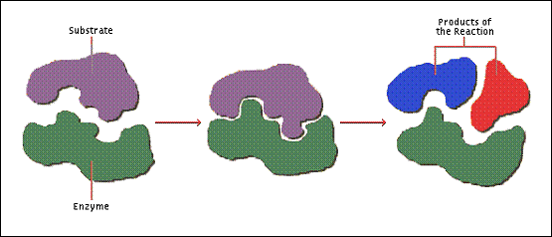
- What were the controls in the experiment?

- When Hydrogen peroxide was on its own, did it react? If so how fast?

- Why did adding the liver to the hydrogen peroxide – increase the rate of the reaction?

- Why did the reused liver still cause a reaction – but it was slower?

- Why was the puree faster than the control?

- Why was the boiled liver slower than the control?

- Why was the liver in acid slower than the control?

- Why was the liver in the base slower than the control?

- What does it mean that catalase lowered the activation energy of the reaction?

Understanding Diagrams
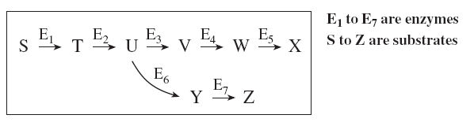
- What is the following? ___________________

- In the diagram above what does E represent _____________, S _____________, X and Z __________________

- If E is denated – what is happen to the quantities of:
Z: ___________________
W: __________________
- In the graph below:
  - The rate levels out between X and Y – why?

  - What happened to cause A?

  - What happened to cause B?
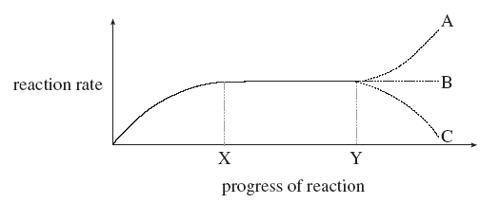
  - What happened to cause C?

