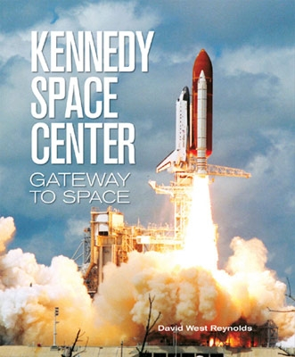
Where: Orlando, Florida
What: Science and Business “Edventure”

Website: http://mrstowers.weebly.com/orlando-2017.html
Information video: http://bit.ly/orlandopromo

Visit local theme parks and attractions – including their education programs:
- Business & Leadership Excellence – Epcot
- Physics: Properties of Motion – Disney’s Magic Kingdom
- The Business & Science of the Production Arts – Disney’s Hollywood Studios
- Zoology and Botany – Disney’s Animal Kingdom
- Roller Coaster Physics and Engineering – Islands of Adventure
- Marketing and Finance – Universal Studios
- Aerospace Science – Kennedy Space Center (NASA)
- Anatomy of Performance – Cirque du Soleil – Downtown Disney
When: April 7-14, 2017 (returning on Good Friday)
Who: This year’s Grade 10 and 11 – Science or Business students who are in good standing. With 3 fabulous chaperones – Mr. Dickinson, Mr. Lawson and Mrs. Towers
Why: See Science and Business in action, explore the subjects more deeply, personal growth
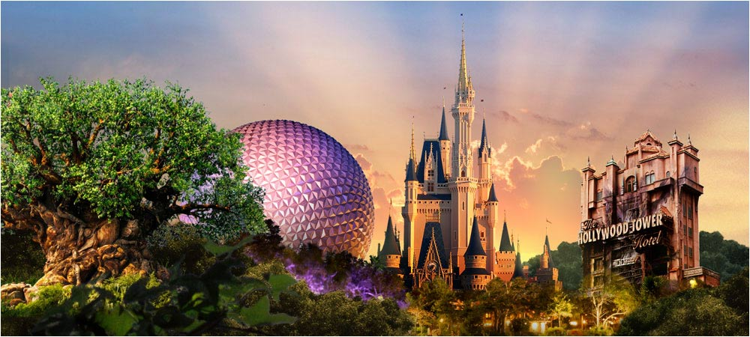
How much: Approx. $3000 CDN
What to do next?
Fill out the application (attached) and bring it along with the deposit ($500) to the parent meeting October 6th at 6:30 in the library.

