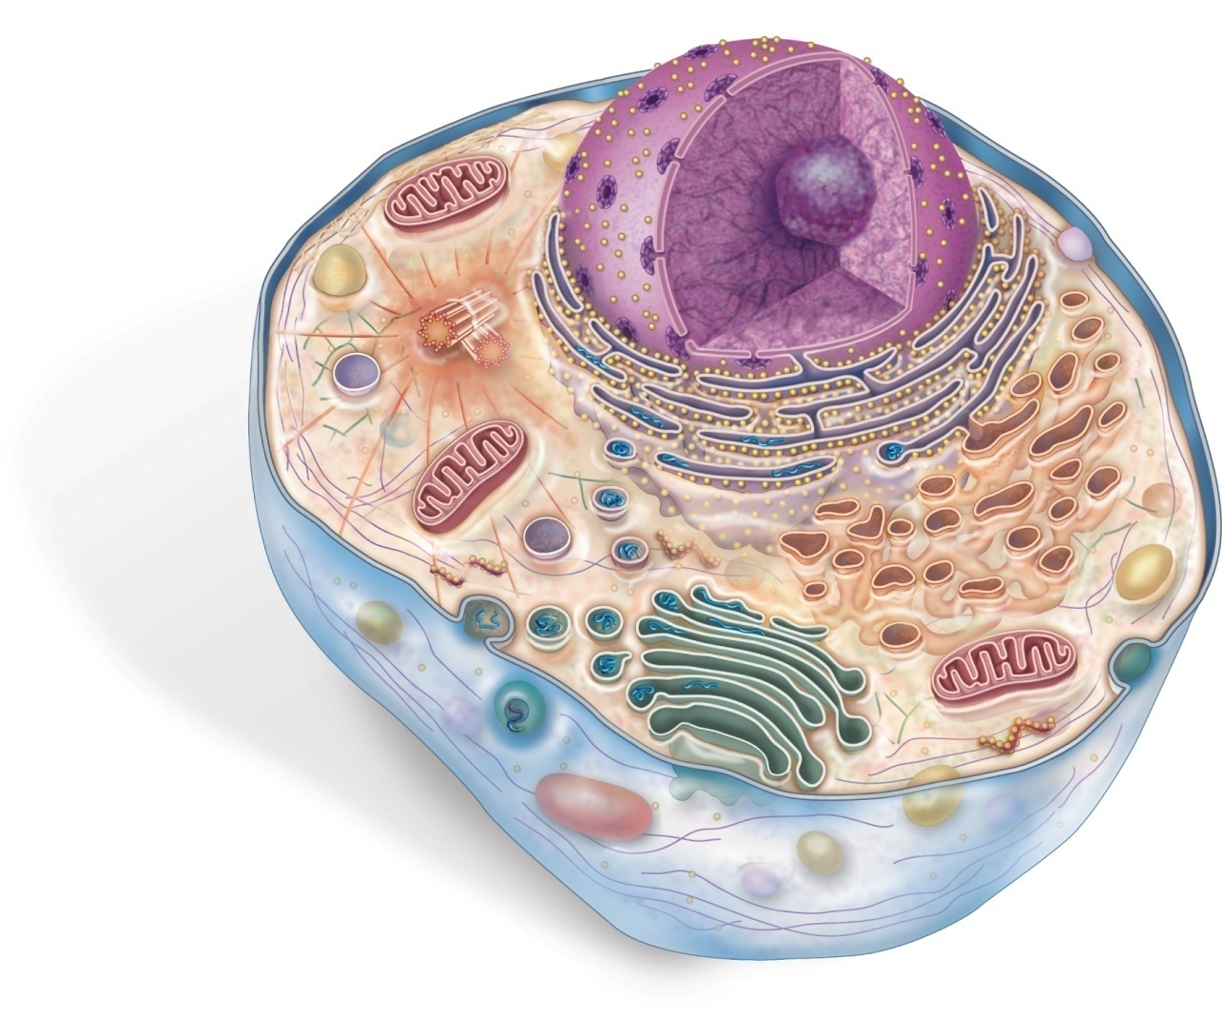
Try This #2
A
Label each organelle and give the function
B

C
D

