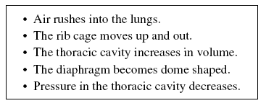**Try This #3**

1. Which of the following occur during exhalation and which occur during inhalation?



1. What is going on in each section of the following graph?

