Try This #3 - ANSWERS

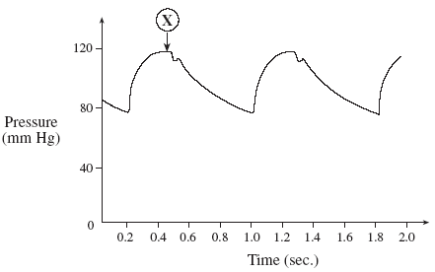
What accounts for the blood pressure recorded at X?
  - The AV valves are opening.
  - The ventricles are in diastole.
  - The ventricles are contracting.
  - Blood is entering the ventricles.
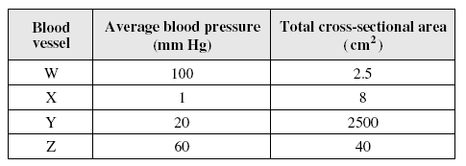
- Through which vessel would blood move most slowly? Y

- What happens during atrial diastole?
  - Atria fill with blood. B. Semi-lunar valves close. C. Ventricles fill with blood. D. Atrioventricular valves open.

- Put the following in order: 1. Systole of the ventricles. 2. Opening of the atrio-ventricular valves. 3. Electrical impulse sent from the SA node. 4. Atria fill with blood. _4, 3, 2, 1

- Hypertension would be indicated by a blood pressure reading of A. 100 / 80 B. 120 / 50 C. 120 / 80 D. 150 / 110

- The highest blood pressure in the aorta occurs when the A. atria contract. B. heart muscle is relaxed. C. blood is pushed to the ventricle. D. blood is pumped from the heart.

- Which of the following is not found in the lymphatic system? A. Veins. B. Nodes. C. Arteries. D. Capillaries.

