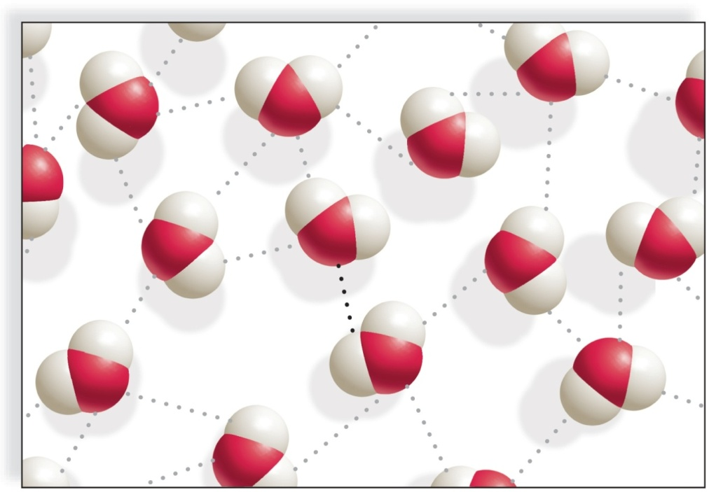
Try This #5
- What is this?

- Label oxygen, hydrogen, hydrogen bond and the polarity.

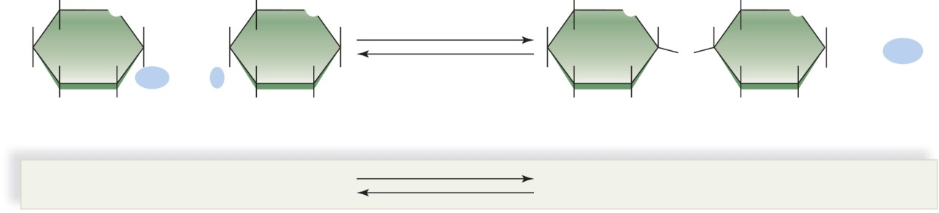
- What are the green shapes below?
+
+
O
- Fill in the blue circles with the appropriate molecules.
- Label the arrows as dehydration synthesis and hydrolysis.

