**Try This #8 – Diagrams - KEY**

What type of transport is shown in the diagram below? What is X and what is most likely inside it?



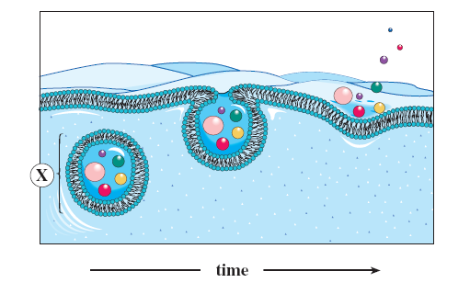



In the following diagram - label the H and L concentration of water. What type of solution is found in the beaker. What will happen to the water level in the tube and why?



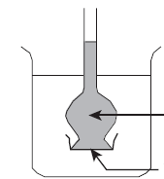



40% salt

Semi permeable membrane

20% salt