UNIT 1 CONCEPT OVERVIEW
Cells, Biological Molecules, and Membranes
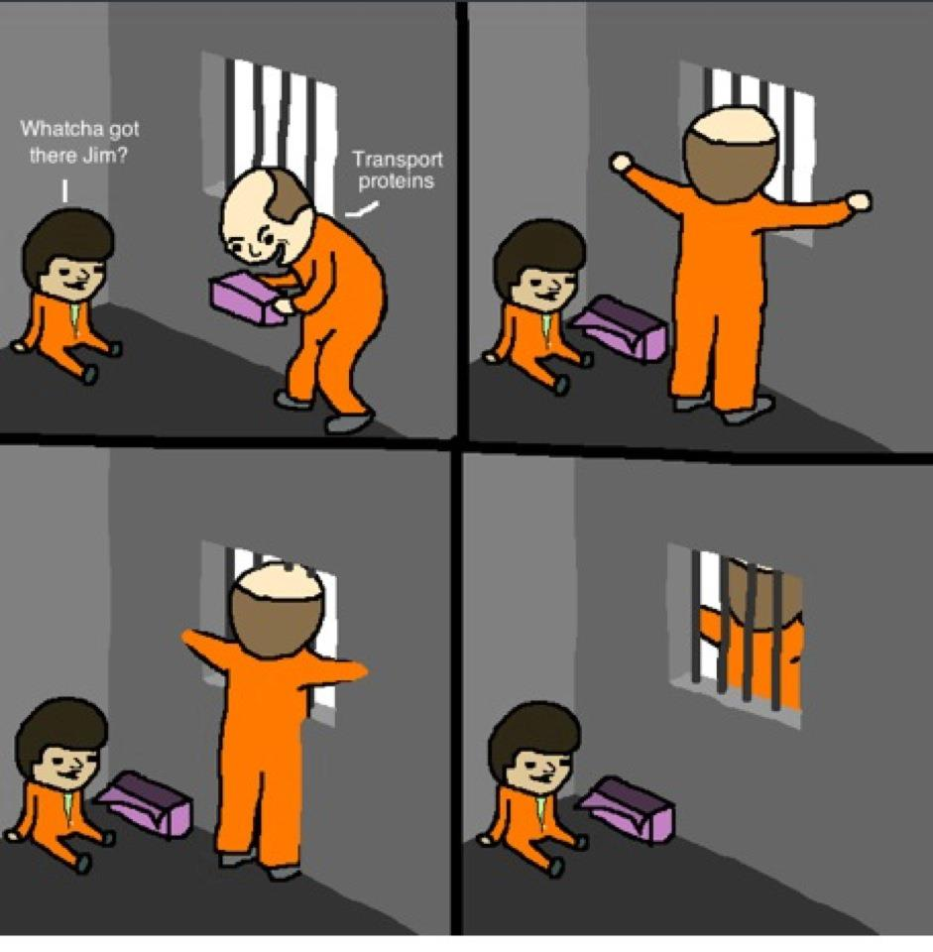
# | Concept & Elaborations
1-1 | Cell structures and functions and the interrelationships of cell structures  - Prokaryotic vs. Eukaryotic Cells  - Cell Structures & their Functions  - Relationships between cell structures  - Diagrams & Microscopic Imagery
1-2 | Characteristics of water and its role in biological systems  - polarity  - bonding  - solvent  - temperature regulator  - lubricant
1-3 | Biological molecules including:  - carbohydrates  - lipids  - ATP  - dehydration synthesis and hydrolysis reactions
1-4 | Structure and function of the cell membrane  - Fluid-Mosaic Model  - Function of Membrane Components  - Diffusion, Osmosis, Facilitated Transport, Active Transport, Endocytosis, Exocytosis  - Tonicity  - Factors Affecting Transport
1-5 | Cell size  - surface area-to-volume ratio

UNIT 1 REVIEW
CELLS, BIOLOGICAL MOLECULES (Lipids and Carbs), MEMBRANES
The following worksheet is intended to augment your revision for the upcoming unit test. It is essential that you understand all the learning outcomes in each component of unit 1.

- How do the inner membrane of the mitochondria and the nuclear envelope differ?
- What produces the molecules of which ribosomes are composed? What is the role of ribosomes?
- Draw the structure of the glucose molecule.
- Why do neutral fats not dissolve in water?
- Explain how four different factors would affect the rate of diffusion of molecules crossing a cell membrane.
- If a 0.9% solution is isotonic to a certain type of animal cell, the cell will lose mass if it is placed in which of the following liquids?

- 0.5% salt solution
- 0.9% salt solution
- 1.2% salt solution
- distilled (pure) water

- Which of the part of a cell membrane requires the breakdown of ATP for the active transport of sodium ions?
- Why do the heads of the phospholipids point out and the tails point in to each other?
- Within the fluid mosaic model of the plasma membrane, what is the role of carrier and channel proteins? How are they similar, and how are they different?
- If the red blood cells are taken from the body and placed in a hypotonic solution, what happens to the cells?
- Solutions that cause water to leave cells by osmosis are called .
- What is the function of vacuoles?
- Lysosomes can be expected to be present in large numbers in cells which

- have cilia
- produce centrioles
- are actively dividing
- carry out phagocytosis

- Describe how the polarity of water results in hydrogen bonding. Draw a diagram.
- Explain how the endomembrane system is continuous.
- Sketch a graph to show how the % change in the mass of a cell changes with the concentration of solution in which it’s placed.
- Compare exocytosis with endocytosis
- Compare facilitated diffusion with active transport.
- List three functions of lipids.
- Differentiate between saturated and unsaturated fats in terms of their molecular structure.
- What is the general empirical formula for monosaccharides?
- Hydrolysis of neutral fats could produce what?
- Which of the following is an animal carbohydrate?

- glycerol
- glycogen
- dipeptide
- cellulose

- Which of the following diagrams could represent glucose? Maltose?
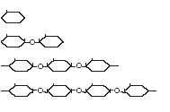
- For the above diagram, how many water molecules would be required to hydrolyze the bottom three molecules into monomers?

