UNIT 2 CONCEPT OVERVIEW
DNA Replication & Protein Synthesis

# | Concept & Elaborations
2-1 | Process of DNA Replication and Recombinant DNA  - Structure of DNA  - Nucleic Acids  - Purpose & Process of DNA Replication  - Structure & Uses of rDNA
2-2 | Process of Protein Synthesis  - Proteins (monomers, polymers, levels of structure, bonding)  - Transcription  - Translation
2-3 | DNA Mutations & their Effects  - Types of mutations & effects on proteins  - Causes of Mutations
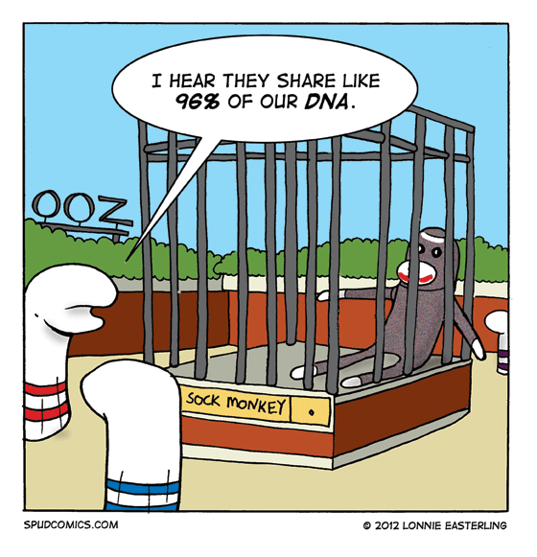

UNIT 2 REVIEW
DNA REPLICATION, BIOLOGICAL MOLECULES (Nucleic Acids & Proteins), PROTEIN SYNTHESIS
The following worksheet is intended to augment your revision for the upcoming unit test. It is essential that you understand all the learning outcomes in each component of unit 2.

- What are the monomers of nucleic acids? What are these monomers composed of?
- Compare and contrast the nucleic acids, DNA and RNA.
- What is the importance of hydrogen bonds in the explanation of the DNA model?
- Define complimentary base pairing and its significance with respect to DNA
- What are the basic steps involved in DNA replication?
- Where are the master instructions for protein synthesis located in a cell?
- DNA is described as a zipper and a corkscrew. Unwound, it looks like a ladder. Of what substances are the rails and rungs composed?
- What are the four possible combinations in the base pairing?
- What is the significance of the complementary base pairing?
- What is the function of DNA in the cell?
- If a DNA molecule is composed of 35% guanine, what is the percentage of adenine?
- What is a cell undergoing DNA replication preparing to do?
- During DNA replication, what is the step in which nucleotides are joined?
- During DNA replication, which bonds are broken? Which bonds are kept intact?
- Explain the term semi-conservative with respect to DNA replication.
- What is recombinant DNA?
- Describe three uses for recombinant DNA
- What is the name for process of copying genetic information from DNA to RNA?
- What is the function of the endoplasmic reticulum?
- Name the building blocks of protein.
- Draw a simplified model of the tRNA molecule.
- What is the function of tRNA?
- Explain the roles of the codon and anticodon.
- How many nucleotides are needed to make a protein of 30 amino acids? Explain.
- If a tRNA moleule had the anticodon GCU, which amino acid would it be carrying?
- If the sequence on the DNA molecule is AGC, what would be the anticodon of the corresponding tRNA molecule?
- Distinguish between transcription and translation in terms of substances involved, main events occuring, and location.
- Transcribe the following sequence of DNA into mRNA and then translate into a polypeptide chain (protein).
DNA: TACCCGAAAGCTGCTTATTATGGGCGC
mRNA:
Protein:
- What are the roles of the following in protein synthesis: tRNA, mRNA, nucleolus
- Match each of the following descriptions to the step in protein synthesis in which they belong:

Ribosome moving along an mRNA molecule
Adenine bonding to thymine
An amino acid bonding to a specific tRNA
Forming of peptide bonds

- Describe the difference between a point mutation and a frameshift mutation. Which one will alter the sequence of amino acids more?
- What are some examples of mutagens?
- Draw and label a dipeptide with peptide bond, amine, acid and R groups.
- Compare and Contrast: primary, secondary, tertiary and quaternary structure.

