**DISTANCE VS TIME – Graphing and Calculating Average Speed**

NAME _______________

DATE ______________

**Scalar examples involving Uniform Motion**

1. A remote control powered car travels along a straight track at a constant speed of 1.5km every minute.

1. Fill in a data table for the first 5 minutes and draw/label a distance vs. time graph.

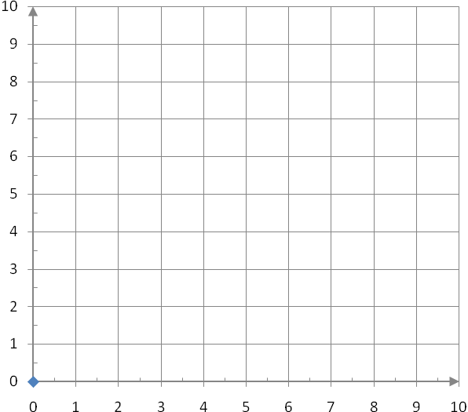

|  |  |
| --- | --- |
| **Time**  **(min)** | **Distance**  **(km)** |
| 0 | 0 |
| 1 |  |
| 2 |  |
| 3 |  |
| 4 |  |
| 5 |  |

distance (km)

1. Calculate the slope of the line



time (min)

1. What is the relationship between the slope of the line of the graph and the speed of the car?
2. The remote control car travels along a straight track at a constant speed of 2km every minute for the first 5 minutes and then suddenly stops for 3 minute.

a) Fill in a data table for the first 8 minutes and draw/label a distance vs time graph.

|  |  |
| --- | --- |
| **Time**  **(min)** | **Distance**  **(km)** |
| 0 | 0 |
| 1 |  |
| 2 |  |
| 3 |  |
| 4 |  |
| 5 |  |
| 6 |  |
| 7 |  |
| 8 |  |



distance (km)

time (min)

b) What is the speed during the first 5 minute? Is this the same as slope?

c) What is the speed of the car during the 5-8 minute?

**Average Speed**

When you travel on a trip you might _________________ several times for things like: fuel, food and bathroom breaks. Your _________________ is also likely changing as you go up hills, around __________________ and through towns. At any given ______________ you can measure your ___________________ speed. But, all these changes prevent you from measuring a constant uniform speed. However you can calculate an average speed:

 Where  is the total change in distance and  is the total change in time

1. The remote control car travels along a straight track at a constant speed of 1 km for every minute for 5 minutes and then suddenly stops for 3 minutes and after that travels 1 more min at 2.5km per minute. Fill in a data table for the first 9 minutes and draw/label a distance vs time graph.

|  |  |
| --- | --- |
| **Time**  **(min)** | **Distance**  **(km)** |
| 0 | 0 |
| 1 |  |
| 2 |  |
| 3 |  |
| 4 |  |
| 5 |  |
| 6 |  |
| 7 |  |
| 8 |  |
| 9 |  |

distance (km)

time (min)

1. What is the total change in distance? _______________________
2. What is the total change in time? _______________________
3. What is the average speed of the RC car? ________________________